Interactive Data structures and Algorithms Visualizer with Integrated Coding IDE


A
Project Report
Submitted in partial fulfillment of the requirement for the award of degree of
Bachelor of Technology
In
Information Technology

Submitted to
RAJIV GANDHI PROUDYOGIKI VISHWAVIDYALAYA,
BHOPAL (M.P.)

Guided By Submitted By
Prof. Manish Vyas Abhinav Patidar (0827IT231006)
Aditya Trivedi (0827IT231014)
Akshat Yadav (0827IT231020)
Archesh Shrivas (0827IT231029)
Aryan Singh (0827IT231033)

DEPARTMENT OF INFORMATION TECHNOLOGY
ACROPOLIS INSTITUTE OF TECHNOLOGY & RESEARCH,
INDORE (M.P.) 453771
2025-2026

Declaration
I hereby declared that the work, which is being presented in the project entitled Interactive Data structures and Algorithms Visualizer with Integrated coding IDE partial fulfillment of the requirement for the award of the degree of Bachelor of Technology, submitted in the department of Information Technology at Acropolis Institute of Technology & Research, Indore is an authentic record of my own work carried under the supervision of “Prof. Manish Vyas”. I have not submitted the matter embodied in this report for the award of any other degree.

Abhinav Patidar(0827IT231006)
Aditya Trivedi (0827IT231014)
Akshat Yadav (0827IT231020)
Archesh Shrivas (0827IT231029)
Aryan Singh (0827IT231020)

Prof. Manish Vyas
Supervisor
Project Approval Form

I hereby recommend that the project Interactive Data structures and Algorithms Visualizer with Integrated coding IDE prepared under my supervision by Aditya Trivedi (0827IT231014), Abhinav Patidar (0827IT231006), Akshat Yadav (0827IT231020), Archesh Shrivas (0827IT231029) and Aryan Singh(0827IT231033) be accepted in partial fulfillment of the requirement for the degree of Bachelor of Technology in Information Technology.

Prof. Manish Vyas
Supervisor

Recommendation concurred in 2025-2026

Prof. Ankita Agrawal
Project Incharge

Prof. Deepak Singh Chouhan
Project Coordinator

Acropolis Institute of Technology & Research
Department of Information Technology


Certificate
The project work entitled Interactive Data structures and Algorithms Visualizer with Integrated coding IDE submitted by Aditya Trivedi (0827IT231014), Abhinav Patidar (0827IT231006), Akshat Yadav (0827IT231020), Archesh Shrivas (0827IT231029) and Aryan Singh(0827IT231033) is approved as partial fulfillment for the award of the degree of Bachelor of Technology in Information Technology by Rajiv Gandhi Proudyogiki Vishwavidyalaya, Bhopal (M.P.).

Internal Examiner External Examiner
Name:………………. Name: ……………..
Date: …./…/……….. Date: …./…/………..

Acknowledgement

With boundless love and appreciation, we/I would like to extend our/my heartfelt gratitude and appreciation to the people who helped us/me to bring this work to reality. We/I would like to have some space of acknowledgement for them.
Foremost, I would like to express my sincere gratitude to my supervisor, Prof. Manish Vyas whose expertise, consistent guidance, ample time spent and consistent advice that helped us/me to bring this study into success.
To the project in-charge Prof. Ankita Agrawal and project coordinator Prof. Deepak Singh Chouhan for their constructive comments, suggestions, and critiquing even in hardship.
To the honorable Prof. (Dr.) Prashant Lakkadwala, Head, Department of Information Technology for his favorable responses regarding the study and providing necessary facilities.
To the honorable Dr. S.C. Sharma, Director, AITR, Indore for his unending support, advice and effort to make it possible.
Finally, I would like to pay my thanks to faculty members and staff of the Department of Computer Science & Engineering for their timely help and support.
Aditya Trivedi (0827IT231014)
Abhinav Patidar(0827IT231006)
Akshat Yadav (0827IT231020)
Archesh Shrivas (0827IT231029)
Aryan Singh (0827IT231020)

Abstract
Data Structures and Algorithms (DSA) are fundamental concepts in computer science and software engineering. Despite their importance, many students find it difficult to understand algorithm execution and data structure behavior through traditional teaching methods that rely heavily on theoretical explanations and static examples. To address this challenge, this project presents an AI-Powered Interactive Data Structures and Algorithms Visualizer with an Integrated Python IDE, a web-based educational platform designed to improve conceptual understanding through visualization, practical coding, and intelligent learning assistance.
The proposed system combines an interactive coding environment with real-time algorithm visualization and Artificial Intelligence based analysis. Unlike conventional DSA visualizers, the platform allows users to write, edit, and execute Python code directly inside an integrated IDE playground. The execution process is simultaneously represented through dynamic visualizations, enabling learners to observe how data structures and algorithms operate internally step by step.
A key feature of the system is the integration of Google Gemini 2.0 Flash, which acts as an intelligent learning assistant. The AI module analyzes user-written code and provides algorithm explanations, complexity analysis, debugging assistance, optimization suggestions, and learning guidance. This enables students not only to observe algorithm execution but also to understand the reasoning behind implementation choices and performance characteristics.
The platform supports a wide range of data structures and algorithms including Arrays, Linked Lists, Stacks, Queues, Trees, Graphs, Sorting Algorithms, Searching Algorithms, and Graph Traversal Techniques. Users can customize inputs, control visualization speed, execute code, and request AI-powered explanations through a single interface. The system follows a modular architecture consisting of a React-based frontend, Python backend services, visualization modules, and AI integration through Gemini 2.0 Flash APIs.
The primary objective of this project is to bridge the gap between theoretical learning and practical implementation by combining coding, visualization, and artificial intelligence into a unified learning platform. The proposed solution promotes active learning, improves problem-solving skills, enhances algorithmic thinking, and provides students with an engaging environment for mastering Data Structures and Algorithms.
Future enhancements may include support for additional programming languages, local Large Language Models (LLMs), collaborative learning features, personalized learning pathways, and advanced algorithm simulation capabilities.

Table of Content

Declaration ............................................................................................. i
Project Approval Form ............................................................................. ii
Certificate .............................................................................................. iii
Acknowledgement ................................................................................... iv
Abstract .................................................................................................. v
List of Figures ......................................................................................... vi
List of Tables .......................................................................................... vii
CHAPTER 1: INTRODUCTION ............................................................. 1
1.1 Introduction ...................................................................................... 1
1.2 Existing System and Limitations ......................................................... 3
1.3 Problem Definition ............................................................................ 5
1.4 Proposed Solution ............................................................................ 7
1.5 Objectives of the Study .................................................................... 9
1.6 Scope of the Study .......................................................................... 10
1.7 Significance of the Project ............................................................... 11
1.8 Organization of the Report .............................................................. 12
CHAPTER 2: REQUIREMENT ENGINEERING ..................................... 13
2.1 Overview ......................................................................................... 13
2.2 Requirement Gathering Methodology ............................................... 14
2.3 Literature Supported Requirement Insights ...................................... 16
2.4 Functional Requirements ................................................................. 18
2.5 Non-Functional Requirements .......................................................... 21
2.6 Hardware and Software Requirements ............................................. 23
2.7 Use Case Diagram ........................................................................... 25
2.7.1 Use Case Description ................................................................... 26
2.8 Use Case Specification .................................................................... 28
2.9 Feasibility Analysis .......................................................................... 32
2.10 Stakeholder Requirement Matrix .................................................... 35
2.11 Risk Analysis and Constraints ......................................................... 37
2.12 Chapter Summary .......................................................................... 39
CHAPTER 3: ANALYSIS, SYSTEM DESIGN AND TECHNICAL ARCHITECTURE ............................................................................... 40
3.1 Overall System Architecture ............................................................ 40
3.2 Module Decomposition and Responsibilities ..................................... 44
3.3 Sequence Diagram ........................................................................... 48
3.4 Data Flow Diagram .......................................................................... 51
3.5 Data Management Design ............................................................... 55
3.6 User Interface Design ...................................................................... 58
3.7 System Workflow ............................................................................ 62
3.8 Chapter Summary ............................................................................ 64
CHAPTER 4: IMPLEMENTATION, TESTING AND RESULTS ................. 65
4.1 Introduction .................................................................................... 65
4.2 Technology Stack ............................................................................ 66
4.3 Development Environment ............................................................... 68
4.4 System Implementation ................................................................... 70
4.4.1 Frontend Implementation .............................................................. 71
4.4.2 Backend Implementation ............................................................... 73
4.4.3 Visualization Engine Implementation ............................................. 75
4.4.4 AI Integration Module ................................................................... 77
4.5 User Interface Screens .................................................................... 80
4.6 Testing Methodology ....................................................................... 84
4.7 Test Cases and Results .................................................................... 86
4.8 Performance Evaluation ................................................................... 90
4.9 Results and Discussion .................................................................... 92
4.10 Chapter Summary .......................................................................... 95
CHAPTER 5: RESULTS, DATA ANALYSIS, CONCLUSION AND FUTURE SCOPE ............................................................................................. 96
5.1 Results and Data Analysis ................................................................. 96
5.2 Discussion ....................................................................................... 99
5.3 Conclusion ...................................................................................... 102
5.4 Limitations of the Current System .................................................... 104
5.5 Future Scope ................................................................................... 106
5.6 Final Project Summary .................................................................... 109
References ............................................................................................ 111
Appendix A – Source Code Screenshots ................................................. 114
Appendix B – API Integration Details ...................................................... 118
Appendix C – Test Cases and Output Screens ......................................... 122

CHAPTER 1

INTRODUCTION
  - Background and Rationale
Data Structures and Algorithms (DSA) form the foundation of computer science and software engineering. They play a critical role in designing efficient software systems, optimizing computational resources, and solving complex real-world problems. A strong understanding of DSA is essential for students, software developers, and technology professionals because these concepts directly influence application performance, scalability, and maintainability.
Despite their importance, many learners struggle to understand how algorithms and data structures operate internally. Traditional learning methods primarily rely on textbooks, classroom lectures, static diagrams, and source code examples. While these approaches explain theoretical concepts, they often fail to demonstrate the dynamic behavior of algorithms during execution. Students can observe the input and final output of a program but frequently encounter difficulties understanding intermediate execution steps, memory manipulation, data movement, recursive operations, and algorithmic decision-making processes.
In recent years, algorithm visualization tools have emerged as effective educational resources for improving conceptual understanding. By graphically representing algorithm execution, visualizers allow learners to observe operations such as sorting, searching, insertion, deletion, traversal, and graph exploration in real time. However, most existing visualization platforms provide only predefined demonstrations and limited customization options. Learners often need to switch between multiple applications for coding, execution, debugging, visualization, and conceptual learning, resulting in a fragmented educational experience.
At the same time, advances in Artificial Intelligence and Large Language Models (LLMs) have created new opportunities for personalized and interactive learning. Modern AI systems are capable of understanding source code, explaining algorithm behavior, identifying errors, analyzing computational complexity, and providing optimization recommendations. These capabilities can significantly enhance the learning process by offering instant feedback and intelligent guidance tailored to individual learners.
To address these challenges, the proposed project, “AI-Powered Interactive Data Structures and Algorithms Visualizer with Integrated Python IDE,” combines algorithm visualization, practical coding, and AI-assisted learning within a unified platform. The system provides an integrated Python IDE where users can write, edit, and execute code while simultaneously observing real-time visual representations of algorithm execution. In addition, the platform incorporates Google Gemini 2.0 Flash as an intelligent analysis engine capable of explaining code, evaluating algorithm complexity, providing debugging assistance, and generating educational insights.
The platform supports multiple data structures including Arrays, Linked Lists, Stacks, Queues, Trees, and Graphs, along with important algorithms such as Searching Algorithms, Sorting Algorithms, Tree Traversals, and Graph Traversal Techniques. Users can execute code, control visualization speed, analyze performance, and obtain AI-generated explanations through a single interface.
The project is developed using modern web technologies, including React.js for the frontend, Python-based backend services for execution and processing, visualization modules for graphical representation, and Gemini 2.0 Flash APIs for intelligent code analysis. By integrating coding, visualization, and artificial intelligence into a single educational ecosystem, the system aims to bridge the gap between theoretical understanding and practical implementation while making DSA learning more engaging, interactive, and effective.

Existing System and Limitations
Several online platforms and software tools currently assist students in learning Data Structures and Algorithms (DSA). These solutions generally belong to three major categories: coding practice platforms, algorithm visualization tools, and integrated development environments (IDEs).
Coding practice platforms such as LeetCode, HackerRank, CodeChef, and GeeksforGeeks provide users with programming challenges, coding exercises, and automated evaluation systems. These platforms are highly effective for improving problem-solving skills and interview preparation. However, they primarily focus on obtaining correct outputs and performance metrics rather than helping learners understand the internal execution of algorithms. Students can solve problems and receive feedback on correctness, but they often struggle to visualize how data structures change throughout the execution process.
Algorithm visualization tools such as VisuAlgo and Algorithm Visualizer provide graphical demonstrations of various sorting, searching, graph traversal, and tree operations. These platforms help learners understand algorithm behavior through animations and step-by-step execution. While they improve conceptual understanding, they generally support only predefined algorithms and offer limited flexibility for executing custom user-written code. Most visualizers function as demonstration tools rather than complete learning environments.
Traditional Integrated Development Environments (IDEs) such as Visual Studio Code, IntelliJ IDEA, Eclipse, and PyCharm provide powerful coding, debugging, and project management capabilities. These tools are widely used by developers for software development and testing. However, they are not specifically designed for DSA education and do not provide built-in visualization features or educational guidance for understanding algorithm execution.
Recent advancements in Artificial Intelligence have introduced AI-powered coding assistants capable of code generation, explanation, and debugging. While these tools provide valuable programming support, they generally lack dedicated algorithm visualization capabilities and do not focus specifically on DSA learning. As a result, learners still need to use multiple platforms to write code, visualize execution, understand algorithm behavior, and obtain conceptual explanations.
The limitations of existing systems can be summarized as follows:
• Separation of coding and visualization: Most platforms focus either on coding practice or algorithm visualization, requiring users to switch between multiple applications.
• Limited support for custom implementations: Many visualization tools only demonstrate predefined algorithms and do not support user-written code execution.
• Lack of intelligent learning assistance: Existing visualizers generally do not provide AI-powered explanations, debugging support, or complexity analysis.
• Fragmented learning experience: Students often use separate tools for coding, execution, visualization, learning resources, and performance analysis.
• Insufficient conceptual guidance: Most platforms provide outputs without explaining why an algorithm behaves in a particular manner or how it can be optimized.
• Limited personalization: Existing systems rarely adapt explanations or learning support according to the user's code and learning requirements.
To overcome these limitations, the proposed AI-Powered Interactive Data Structures and Algorithms Visualizer with Integrated Python IDE combines algorithm visualization, code execution, and AI-assisted learning within a single platform. The system enables learners to write Python code, execute algorithms, observe real-time visualizations, and obtain intelligent explanations through Google Gemini 2.0 Flash, creating a comprehensive and interactive learning environment.
Following is the comparison table of other available applications:-
Feature | Coding Platforms (LeetCode/HackerRank) | DSA Visualizers (VisuAlgo) | Traditional IDEs | Proposed System
Code Execution | Yes | Limited | Yes | Yes
Real-Time Visualization | No | Yes | No | Yes
Custom User Code Support | Yes | Limited | Yes | Yes
AI-Powered Explanation | No | No | No | Yes
Complexity Analysis | Limited | No | No | Yes
Debugging Assistance | Basic | No | Yes | Yes
Integrated Learning Environment | No | No | No | Yes
DSA-Focused Design | Partial | Yes | No | Yes
Interactive IDE | Basic | No | Yes | Yes
Personalized Learning Support | No | No | No | Yes

  - Problem Definition
Data Structures and Algorithms (DSA) are among the most important subjects in computer science and software engineering. They form the foundation of efficient programming, software design, and computational problem-solving. Despite their significance, a large number of students face difficulties in understanding the practical implementation and execution behavior of data structures and algorithms. While learners can often understand the syntax of a program and observe its final output, they frequently struggle to comprehend the intermediate steps and internal operations that occur during execution.
Traditional learning approaches primarily rely on textbooks, classroom lectures, static diagrams, and written examples. These methods are effective for introducing theoretical concepts but often fail to provide a clear understanding of how algorithms manipulate data in real time. Concepts such as recursion, sorting mechanisms, tree traversals, graph algorithms, memory allocation, and data structure operations are inherently dynamic and therefore difficult to understand through static content alone.
Existing educational tools partially address this challenge. Coding platforms allow students to practice programming problems and evaluate solutions, while visualization tools demonstrate algorithm behavior through predefined animations. However, these systems generally operate independently and do not provide a unified learning environment. As a result, students are required to switch between multiple applications for coding, execution, visualization, debugging, and conceptual learning. This fragmented workflow increases cognitive load and reduces learning efficiency.
Another significant limitation of current systems is the lack of intelligent educational assistance. Most platforms provide execution results without explaining algorithm behavior, computational complexity, optimization opportunities, or implementation mistakes. Learners often encounter errors and inefficient solutions but receive limited guidance regarding the underlying causes and possible improvements. Consequently, students may memorize algorithms without developing a deeper understanding of the reasoning behind them.
Furthermore, modern software development increasingly utilizes Artificial Intelligence to support learning and programming activities. Despite these advancements, most DSA learning platforms do not effectively integrate AI-powered educational support with visualization and practical coding environments.
Therefore, there exists a need for an intelligent and integrated platform that combines coding, visualization, execution, and AI-assisted learning into a single educational environment. The proposed AI-Powered Interactive Data Structures and Algorithms Visualizer with Integrated Python IDE addresses this need by enabling users to write and execute code, visualize algorithm execution in real time, and obtain AI-generated explanations, complexity analysis, debugging assistance, and optimization suggestions through Google Gemini 2.0 Flash.
The primary problem addressed by this project can therefore be stated as follows:
“How can an integrated educational platform be developed that combines coding, real-time algorithm visualization, and AI-powered learning assistance to improve the understanding, implementation, and analysis of Data Structures and Algorithms?”
The proposed solution seeks to bridge the gap between theoretical knowledge and practical implementation while creating a more engaging, interactive, and effective learning experience for students, educators, and programming enthusiasts.

Proposed Solution
To address the challenges associated with learning Data Structures and Algorithms (DSA), the proposed project introduces an AI-Powered Interactive Data Structures and Algorithms Visualizer with Integrated Python IDE. The system is designed as a web-based educational platform that combines practical coding, real-time visualization, and Artificial Intelligence assisted learning within a unified environment. The primary objective of the platform is to simplify complex DSA concepts and provide learners with a more interactive and engaging learning experience.
Unlike conventional DSA visualizers that only demonstrate predefined algorithms, the proposed system provides an integrated Python IDE where users can write, edit, and execute their own code. This enables learners to experiment with custom implementations and immediately observe the impact of their code through dynamic visualizations. By allowing users to directly interact with algorithms, the platform promotes active learning and strengthens conceptual understanding.
A key feature of the proposed solution is the integration of Google Gemini 2.0 Flash, which functions as an intelligent educational assistant. The AI module analyzes user-written code and provides detailed explanations of algorithm behavior, identifies the underlying algorithm being implemented, estimates time and space complexity, highlights potential errors, and suggests optimization opportunities. This transforms the platform from a traditional visualizer into an intelligent learning environment capable of providing personalized educational support.
The system follows an IDE-first workflow in which users begin their learning process by writing or pasting Python code into the integrated coding environment. Once executed, the code is processed by the backend execution engine, which generates structured execution states. These states are then passed to the visualization engine, where data structure operations and algorithmic steps are represented graphically in real time. Simultaneously, the AI analysis layer communicates with Gemini 2.0 Flash to generate educational insights and explanatory content based on the submitted code.
The platform supports a wide range of commonly used data structures and algorithms, including Arrays, Linked Lists, Stacks, Queues, Trees, Graphs, Sorting Algorithms, Searching Algorithms, Tree Traversals, and Graph Traversal Techniques. Users can modify inputs, control execution speed, observe algorithm behavior step-by-step, and compare different approaches to solving a problem.
The proposed solution is built using modern web technologies. The frontend is developed using React.js to provide a responsive and interactive user interface. The backend is implemented using Python-based services responsible for code execution, data processing, and communication with external AI services. Visualization modules generate graphical representations of algorithm execution, while Google Gemini 2.0 Flash APIs provide intelligent code analysis and educational assistance.
By integrating coding, visualization, and Artificial Intelligence into a single platform, the proposed system eliminates the need for multiple learning tools and creates a comprehensive educational ecosystem. The solution enhances conceptual understanding, improves problem-solving abilities, supports self-paced learning, and helps learners bridge the gap between theoretical knowledge and practical implementation.

Objectives of the Study
The primary objective of this project is to develop an AI-Powered Interactive Data Structures and Algorithms Visualizer with an Integrated Python IDE that enhances the learning experience of students, educators, and programming enthusiasts. The system aims to bridge the gap between theoretical understanding and practical implementation by combining coding, visualization, and Artificial Intelligence within a unified educational platform.
The specific objectives of the study are as follows:
- To develop an integrated Python IDE that allows users to write, edit, and execute Data Structures and Algorithms code within a single environment.
- To provide real-time visualization of data structures and algorithm execution, enabling learners to observe internal operations and execution flow step by step.
- To integrate Google Gemini 2.0 Flash for intelligent code analysis, educational guidance, and personalized learning support.
- To automatically generate algorithm explanations that help users understand the logic, working principles, and execution behavior of implemented solutions.
- To analyze and display time complexity and space complexity information for user-submitted algorithms.
- To provide debugging assistance and optimization recommendations that help learners improve code quality and algorithmic efficiency.
- To support the learning and visualization of commonly used data structures and algorithms, including Arrays, Linked Lists, Stacks, Queues, Trees, Graphs, Searching Algorithms, and Sorting Algorithms.
- To create an interactive and user-friendly educational platform that improves conceptual understanding, problem-solving abilities, and algorithmic thinking.
- To reduce the dependency on multiple learning tools by combining coding, visualization, execution, and AI-assisted learning into a single platform.
- To promote self-paced and active learning through interactive experimentation, real-time feedback, and intelligent educational assistance.

Scope of the Study
The scope of this project focuses on the design and development of an AI-Powered Interactive Data Structures and Algorithms Visualizer with an Integrated Python IDE. The platform is intended to serve as an educational tool that assists students, educators, and programming enthusiasts in understanding Data Structures and Algorithms through a combination of practical coding, real-time visualization, and Artificial Intelligence assisted learning.
The system provides an integrated Python coding environment where users can write, edit, and execute code directly within the platform. The primary focus of the project is to visualize the execution of commonly used data structures and algorithms while simultaneously providing intelligent explanations and learning assistance through AI integration.
The platform supports a range of fundamental data structures including Arrays, Linked Lists, Stacks, Queues, Trees, and Graphs. It also supports important algorithm categories such as Searching Algorithms, Sorting Algorithms, Tree Traversal Algorithms, and Graph Traversal Algorithms. Users can observe algorithm execution step-by-step through graphical representations that illustrate how data is processed and manipulated during runtime.
A significant component of the project is the integration of Google Gemini 2.0 Flash, which enables intelligent analysis of user-written code. The AI module provides code explanations, algorithm identification, complexity analysis, debugging guidance, and optimization suggestions. This feature enhances the educational value of the platform by helping learners understand not only how algorithms work but also why certain implementation choices affect performance and efficiency.
The project is designed primarily for educational and learning purposes rather than large-scale software development or production-grade code execution. The platform aims to support algorithm understanding, experimentation, and practice within an interactive environment. While users can execute Python code related to supported algorithms and data structures, the system does not intend to replace professional development environments or enterprise-level coding platforms.
The current implementation focuses on Python as the primary programming language for code execution and visualization. Support for additional programming languages such as Java, C++, JavaScript, and Go is considered outside the present scope and may be incorporated in future versions of the system.
Similarly, the project does not currently provide advanced collaborative coding features, real-time multi-user sessions, version control integration, cloud deployment pipelines, or large-scale code repository management. The platform is centered on individual learning, algorithm visualization, and AI-assisted educational support.
Despite these limitations, the modular architecture of the proposed system allows future expansion. Additional data structures, algorithms, programming languages, AI models, collaborative learning features, and personalized learning pathways can be integrated without major architectural modifications.
Overall, the scope of the study encompasses the design, development, implementation, and evaluation of an intelligent educational platform that combines coding, visualization, and AI-assisted learning to improve the understanding and practical application of Data Structures and Algorithms.

Significance of the Project
The proposed AI-Powered Interactive Data Structures and Algorithms Visualizer with Integrated Python IDE holds significant educational, technological, and practical value. By combining algorithm visualization, coding practice, and Artificial Intelligence assisted learning within a single platform, the system addresses several challenges faced by students while learning Data Structures and Algorithms. The significance of the project can be understood from the following perspectives:
1.7.1 Educational Significance
Data Structures and Algorithms are often considered challenging subjects due to their abstract nature and dynamic execution behavior. Traditional teaching methods frequently rely on theoretical explanations and static examples, making it difficult for students to understand how algorithms manipulate data during execution.
The proposed platform improves the learning experience by providing real-time visual representations of algorithm execution. Students can observe each operation step-by-step, making complex concepts easier to understand. The integration of AI-generated explanations further enhances learning by providing detailed descriptions, complexity analysis, and conceptual guidance. As a result, learners can develop stronger problem-solving skills, algorithmic thinking, and programming confidence.
1.7.2 Technological Significance
The project demonstrates the effective integration of modern web technologies, visualization systems, and Artificial Intelligence within a unified educational platform. By combining a React-based frontend, Python backend services, visualization modules, and Google Gemini 2.0 Flash, the system showcases how emerging AI technologies can be utilized to improve software education.
The project also illustrates the practical application of Large Language Models (LLMs) in educational environments. Instead of using AI solely for code generation, the platform leverages AI for explanation, analysis, debugging assistance, and personalized learning support, making the learning process more intelligent and interactive.
1.7.3 Practical Significance
Students preparing for academic examinations, coding assessments, competitive programming contests, and technical interviews often struggle to understand the internal behavior of algorithms despite being able to write code. The proposed platform provides a practical environment where users can write code, execute it, visualize its behavior, and receive immediate feedback.
The integrated IDE eliminates the need for multiple learning tools and creates a centralized learning environment. This improves learning efficiency and reduces the effort required to switch between coding platforms, visualizers, documentation resources, and AI assistants.
1.7.4 Research and Innovation Significance
The project introduces an innovative approach to DSA education by integrating Artificial Intelligence directly into the learning workflow. Unlike traditional visualizers that focus only on animation, the proposed system combines algorithm visualization with intelligent code analysis and educational assistance.
The architecture provides a foundation for future research in AI-assisted programming education, adaptive learning systems, intelligent tutoring platforms, and agent-based educational environments. The project demonstrates how AI can be used not only to automate programming tasks but also to improve conceptual understanding and support self-directed learning.
Overall, the project contributes to the advancement of technology-enhanced learning by creating an interactive educational ecosystem that combines visualization, coding practice, and Artificial Intelligence. It has the potential to improve the effectiveness of DSA education while making learning more engaging, accessible, and personalized for a wide range of learners.

Organization of the Report
The project report is organized into six chapters to ensure a systematic and comprehensive presentation of the research, design, development, and evaluation of the proposed AI-Powered Interactive Data Structures and Algorithms Visualizer with Integrated Python IDE.
Chapter 1: Introduction
This chapter introduces the background and rationale of the study, discusses the limitations of existing systems, defines the problem addressed by the project, presents the proposed solution, outlines the objectives and scope of the study, highlights the significance of the project, and provides an overview of the report structure.
Chapter 2: Requirement Engineering
This chapter describes the requirement engineering process followed during the development of the system. It includes requirement gathering methodologies, stakeholder analysis, functional and non-functional requirements, feasibility analysis, hardware and software requirements, use-case modeling, and requirement specifications.
Chapter 3: Analysis, System Design and Technical Architecture
This chapter presents the overall architecture of the proposed system and explains the interaction between various modules. It includes system architecture diagrams, sequence diagrams, data flow diagrams, database design, module decomposition, AI integration architecture, user interface design, and security considerations.
Chapter 4: Implementation and Testing
This chapter discusses the implementation methodology, development tools, technologies used, frontend and backend implementation details, AI integration process, visualization engine development, testing approaches, and validation procedures adopted during system development.
Chapter 5: Results and Discussion
This chapter presents the outputs generated by the developed system, including user interface snapshots, visualization results, AI-generated explanations, performance observations, testing outcomes, and comparative discussions. The effectiveness of the proposed platform in supporting DSA learning is also evaluated.
Chapter 6: Conclusion and Future Scope
This chapter summarizes the achievements of the project, discusses the extent to which the objectives have been achieved, identifies current limitations, and outlines potential future enhancements such as multi-language support, advanced visualization techniques, local Large Language Models (LLMs), collaborative learning features, and personalized educational pathways.
Together, these chapters provide a complete description of the design, development, implementation, and evaluation of the proposed AI-powered educational platform for learning Data Structures and Algorithms.

CHAPTER 2

REQUIREMENT ENGINEERING

2.1 Overview
Requirement Engineering is the process of identifying, analyzing, documenting, validating, and managing the requirements of a software system. For the project “Interactive Data Structures and Algorithms Visualizer with Integrated Coding IDE”, requirement engineering helps in understanding user needs and defining the functionalities that the system must provide.
The main stakeholders of the system include students, teachers, programming learners, and administrators. The requirements gathered from these stakeholders form the foundation for the design and development of the application.

Requirement Gathering Methodology
2.2.1 Introduction
Requirement Engineering is a critical phase of software development that focuses on identifying, analyzing, documenting, and validating the needs and expectations of stakeholders. It serves as the foundation for designing and developing a system that effectively addresses real-world problems while meeting user requirements and technical constraints. A well-defined requirement engineering process ensures that the final system aligns with its intended objectives and provides meaningful value to its users.
In the context of Data Structures and Algorithms (DSA) education, learners often encounter challenges in understanding abstract concepts, algorithm execution flow, computational complexity, and data manipulation processes. Traditional learning methods primarily focus on theoretical explanations and static examples, which may not adequately represent the dynamic nature of algorithm execution. As a result, students frequently experience difficulties in connecting theoretical concepts with practical implementation.
The proposed AI-Powered Interactive Data Structures and Algorithms Visualizer with Integrated Python IDE is designed to address these challenges by combining algorithm visualization, code execution, and Artificial Intelligence assisted learning within a single platform. To ensure that the system effectively fulfills educational and technical objectives, a comprehensive requirement engineering process was conducted to identify user expectations, system functionalities, operational constraints, and performance requirements.
The requirement analysis considered the needs of various stakeholders including students, educators, self-learners, and system administrators. Students require an interactive environment for writing code, visualizing algorithms, understanding execution flow, and receiving intelligent explanations. Educators require a platform that can support teaching activities and demonstrate algorithm behavior effectively. System administrators require maintainable, scalable, and secure system architecture capable of supporting multiple users and future enhancements.
The proposed platform integrates multiple components including an interactive Python IDE, visualization engine, backend execution services, and Google Gemini 2.0 Flash powered AI assistance. These components introduce specific functional and non-functional requirements related to code execution, visualization accuracy, response time, usability, reliability, security, and AI-driven educational support. The system must also provide a seamless user experience by allowing learners to write code, execute algorithms, observe graphical representations, and obtain AI-generated explanations without switching between different applications.
This chapter presents the requirement engineering activities performed during the development of the system. It includes requirement gathering methodology, stakeholder analysis, feasibility analysis, functional and non-functional requirements, hardware and software requirements, use-case modeling, and requirement specifications. These requirements establish the foundation for the system architecture, implementation strategy, and evaluation process discussed in subsequent chapters.
By clearly identifying and documenting system requirements, the project ensures that the developed platform effectively supports DSA learning while maintaining scalability, usability, and future extensibility. The requirement engineering process therefore plays a vital role in transforming the project vision into a practical and technically feasible educational solution.

    - Requirement Gathering Methodology
To ensure that the proposed AI-Powered Interactive Data Structures and Algorithms Visualizer with Integrated Python IDE effectively addresses the challenges faced by learners, educators, and programming enthusiasts, a systematic requirement gathering process was conducted. Due to time and resource constraints, the requirement collection process primarily relied on secondary research, analysis of existing educational platforms, academic literature, technical documentation, and user feedback available through online communities and educational forums.
The objective of the requirement gathering process was to identify the limitations of existing DSA learning platforms, understand user expectations, and define the functional and non-functional requirements necessary for developing an effective educational solution.
Requirements for the proposed system were derived from the following sources:
• Educational platforms such as LeetCode, HackerRank, CodeChef, GeeksforGeeks, and InterviewBit, which provided insights into coding practice environments and common challenges faced by learners during algorithm implementation.
• Algorithm visualization platforms such as VisuAlgo and Algorithm Visualizer, which demonstrated existing approaches to graphical representation of data structures and algorithm execution.
• Research papers, journal articles, and academic publications related to DSA education, visualization-based learning, educational technologies, and intelligent tutoring systems.
• Documentation and case studies related to Artificial Intelligence assisted learning systems and Large Language Models (LLMs), highlighting the potential benefits of AI-generated explanations, debugging assistance, and personalized educational support.
• Online developer communities, discussion forums, and student learning groups where learners frequently discuss challenges related to understanding algorithms, debugging code, and preparing for technical interviews.
• Technical documentation for modern web development frameworks, Python execution environments, visualization libraries, and Google Gemini 2.0 Flash APIs used during system development.
• Educational content from universities, coding bootcamps, online learning platforms, and competitive programming communities that emphasize the importance of interactive and practical learning approaches.
The analysis of these sources revealed several common requirements. Learners require an environment where they can write code, execute algorithms, visualize execution flow, understand algorithm behavior, and receive immediate educational feedback. Educators require a platform capable of demonstrating complex concepts through interactive visualizations and step-by-step execution. Developers and system administrators require a scalable, maintainable, and extensible architecture capable of supporting future enhancements.
The collected requirements highlighted the need for a unified platform that integrates coding, visualization, execution, and Artificial Intelligence assistance. These findings formed the basis for defining stakeholder requirements, functional requirements, non-functional requirements, feasibility analysis, and system specifications presented in the subsequent sections of this chapter.
The requirement gathering process ensured that the proposed system is not only technically feasible but also aligned with the educational objectives and practical expectations of its intended users.
Stakeholder | Core Requirements / Expectations
Students | Interactive coding environment, algorithm visualization, AI explanations, debugging assistance, complexity analysis, easy-to-use interface
Educators | Effective teaching tool, step-by-step visualization, classroom demonstrations, conceptual explanations
Self-Learners | Independent learning support, code analysis, personalized explanations, progress improvement
System Administrators | System reliability, maintainability, scalability, security, user management
Developers | Modular architecture, API integration, extensibility, efficient backend processing
Academic Institutions | Educational value, curriculum support, practical learning environment

2.3 Literature-Supported Requirement Insights
Recent studies in computer science education, visualization-based learning, and Artificial Intelligence assisted educational systems have highlighted several challenges associated with learning Data Structures and Algorithms. Research indicates that learners often struggle to understand algorithm execution and data manipulation processes when concepts are presented solely through theoretical explanations or static examples. Visualization techniques and intelligent educational systems have been shown to improve conceptual understanding, engagement, and learning outcomes.
The findings from educational research and existing technology platforms provide valuable insights for defining the requirements of the proposed system. These insights help ensure that the platform addresses real learning challenges while incorporating effective educational practices and modern technological capabilities.
The following table summarizes important findings from literature and their implications for the proposed system design.
Table 2.2 Literature-Supported Requirement Insights
Research Finding | Source Insight | System Impact
Students understand algorithms more effectively when execution steps are visualized. | Visualization improves conceptual learning and retention. | Real-time algorithm visualization must be integrated into the platform.
Interactive learning environments increase student engagement compared to passive learning methods. | Active participation improves understanding and problem-solving ability. | The system should provide an interactive coding and visualization environment.
Learners benefit from immediate feedback while practicing programming concepts. | Timely feedback accelerates learning and error correction. | AI-generated explanations and debugging assistance should be provided.
Many students struggle to understand time and space complexity concepts. | Complexity analysis is often difficult for beginners. | Automatic complexity estimation and explanation should be included.
Educational systems that combine theory and practice improve learning outcomes. | Practical implementation reinforces conceptual understanding. | Coding, execution, and visualization should be integrated within a single platform.
Personalized learning support increases learner confidence and retention. | Tailored explanations improve educational effectiveness. | AI-assisted educational guidance should be incorporated.
Existing DSA platforms often separate coding and visualization. | Fragmented learning environments reduce efficiency. | A unified platform should support coding, visualization, and learning assistance together.
Large Language Models can assist learners by explaining code and programming concepts. | AI can function as an intelligent educational assistant. | Google Gemini 2.0 Flash should provide code explanations and learning support.
Step-by-step demonstrations improve understanding of recursive and graph-based algorithms. | Complex algorithms require visual execution tracking. | Visualization controls and execution state representation should be implemented.
Modern learners prefer web-based educational tools that are accessible across devices. | Accessibility increases adoption and usability. | The platform should be browser-based and user-friendly.

The analysis of these findings confirms that effective DSA learning requires more than code execution alone. Learners benefit significantly from visual representations, intelligent guidance, immediate feedback, and opportunities for experimentation. These insights directly influenced the design decisions of the proposed AI-Powered Interactive Data Structures and Algorithms Visualizer with Integrated Python IDE.
By incorporating visualization, AI-assisted analysis, complexity evaluation, and interactive coding capabilities, the proposed system aligns with established educational research and addresses many of the limitations identified in existing learning platforms.

2.4 Functional Requirements
Functional requirements describe the core operations and services that the proposed AI-Powered Interactive Data Structures and Algorithms Visualizer with Integrated Python IDE must perform. These requirements define how users interact with the system and how the platform responds to various actions. The functional requirements were derived from stakeholder expectations, educational objectives, and technical requirements identified during the requirement gathering process.
The system is designed to provide a unified environment for coding, algorithm visualization, and AI-assisted learning. Therefore, the functional requirements cover code execution, visualization generation, AI analysis, user interaction, and educational support functionalities.
Table 2.3 Functional Requirements
ID | Functional Requirement | Description
FR-1 | User Code Editor | The system shall provide an integrated Python IDE where users can write, edit, and manage code.
FR-2 | Code Execution | The system shall execute user-submitted Python code and generate corresponding outputs.
FR-3 | Input Management | The system shall allow users to provide custom inputs for algorithms and data structures.
FR-4 | Algorithm Visualization | The system shall generate real-time visual representations of supported data structures and algorithms.
FR-5 | Step-by-Step Execution | The system shall display algorithm execution stages sequentially for improved understanding.
FR-6 | Visualization Controls | The system shall allow users to start, pause, resume, reset, and control visualization speed.
FR-7 | AI Code Analysis | The system shall analyze user code using Google Gemini 2.0 Flash.
FR-8 | Algorithm Explanation | The system shall generate AI-powered explanations describing algorithm behavior and execution logic.
FR-9 | Complexity Analysis | The system shall estimate and display time complexity and space complexity information.
FR-10 | Debugging Assistance | The system shall identify common coding mistakes and provide debugging guidance.
FR-11 | Optimization Suggestions | The system shall recommend possible improvements for algorithm efficiency and code quality.
FR-12 | Data Structure Support | The system shall support visualization of Arrays, Linked Lists, Stacks, Queues, Trees, and Graphs.
FR-13 | Algorithm Support | The system shall support Searching, Sorting, Tree Traversal, and Graph Traversal algorithms.
FR-14 | Result Display | The system shall present execution results, visualizations, and AI-generated insights in a unified interface.
FR-15 | Error Handling | The system shall display meaningful error messages for invalid inputs or execution failures.
FR-16 | Responsive User Interface | The system shall provide a user-friendly and responsive web interface across devices.
FR-17 | API Communication | The system shall communicate with Gemini 2.0 Flash APIs for AI-based analysis and educational support.
FR-18 | Session Management | The system shall maintain user interactions during active sessions.
FR-19 | Educational Guidance | The system shall provide learning-oriented explanations suitable for students and beginners.
FR-20 | Future Extensibility | The system architecture shall support integration of additional algorithms, visualizations, and AI features.

2.4.1 Statement of Functionality
The proposed system integrates multiple educational and technical functionalities into a single platform. Users begin by writing or importing Python code into the integrated IDE. The code is executed through the backend execution engine, which generates outputs and execution states. These states are processed by the visualization engine to create graphical representations of algorithm behavior.
Simultaneously, the system communicates with Google Gemini 2.0 Flash to perform intelligent code analysis. The AI module generates explanations, identifies implemented algorithms, evaluates complexity metrics, suggests optimizations, and provides debugging support. The resulting information is displayed alongside the visualization and execution output, enabling users to understand both the implementation and execution aspects of Data Structures and Algorithms.
The combination of execution, visualization, and AI-assisted learning creates a comprehensive educational environment that supports practical learning, conceptual understanding, and problem-solving skill development.

2.5 Non-Functional Requirements
Non-functional requirements define the quality attributes, operational characteristics, and performance expectations of the proposed AI-Powered Interactive Data Structures and Algorithms Visualizer with Integrated Python IDE. These requirements ensure that the system remains reliable, efficient, secure, maintainable, and user-friendly while delivering educational value to its users.
Unlike functional requirements, which describe what the system should do, non-functional requirements specify how the system should perform under various conditions. These requirements are essential for ensuring a positive user experience and long-term system sustainability.
Table 2.4 Non-Functional Requirements
ID | Non-Functional Requirement | Description
NFR-1 | Performance | The system shall provide fast code execution and visualization response times.
NFR-2 | Reliability | The system shall operate consistently without unexpected failures during normal usage.
NFR-3 | Availability | The platform shall remain accessible whenever users need educational support.
NFR-4 | Usability | The user interface shall be intuitive and easy to navigate for students and educators.
NFR-5 | Scalability | The architecture shall support future expansion of algorithms, visualizations, and AI features.
NFR-6 | Maintainability | The codebase shall be modular and easy to update, test, and maintain.
NFR-7 | Security | User interactions and API communications shall be protected from unauthorized access.
NFR-8 | Compatibility | The system shall function across modern web browsers and operating systems.
NFR-9 | Extensibility | New algorithms, data structures, and AI modules shall be integrated without major redesign.
NFR-10 | Accuracy | Visualizations and AI-generated explanations shall accurately represent algorithm behavior.
NFR-11 | Responsiveness | The platform shall respond quickly to user actions and visualization controls.
NFR-12 | Accessibility | The interface shall be designed to support learners with varying levels of technical knowledge.
NFR-13 | Portability | The web-based system shall be accessible from different devices without installation requirements.
NFR-14 | Interoperability | The platform shall communicate effectively with external AI services and APIs.
NFR-15 | Educational Effectiveness | The system shall support meaningful learning through clear visualizations and explanations.

2.5.1 Statement of Non-Functional Requirements
Performance is a critical requirement because users expect visualizations and AI-generated explanations to be delivered within a reasonable time frame. Delays in execution or visualization may negatively affect the learning experience. Therefore, the backend execution engine and visualization modules must process requests efficiently.
Reliability ensures that users can consistently utilize the platform without interruptions. Since the system is intended for educational purposes, failures during algorithm execution or visualization should be minimized through proper exception handling and system monitoring.
Usability is particularly important because the target audience includes beginners who may have limited programming experience. The interface should provide clear navigation, organized layouts, and straightforward controls for execution, visualization, and AI analysis.
Scalability and extensibility allow the platform to accommodate future enhancements such as additional algorithms, support for multiple programming languages, collaborative learning features, and integration with local Large Language Models (LLMs).
Security considerations include secure API communication, protection of user-submitted code, and prevention of unauthorized system access. Although the platform is educational in nature, maintaining data integrity and service security remains important.
Maintainability is achieved through modular architecture, allowing frontend components, backend services, visualization modules, and AI integrations to be updated independently. This approach simplifies future development and reduces maintenance complexity.
Educational effectiveness remains one of the most important quality requirements. The platform should not only function correctly but also improve learner understanding through accurate visualizations, meaningful explanations, and intelligent educational support.
Collectively, these non-functional requirements ensure that the proposed system delivers a reliable, scalable, secure, and effective learning environment for studying Data Structures and Algorithms.

2.6 Hardware and Software Requirements
The successful development and deployment of the AI-Powered Interactive Data Structures and Algorithms Visualizer with Integrated Python IDE require appropriate hardware and software resources. These requirements are categorized into developer requirements and end-user requirements to ensure efficient system development, testing, deployment, and usage.
2.6.1 Hardware Requirements
The hardware requirements define the minimum and recommended specifications necessary for developing and using the proposed system.
Table 2.5 Hardware Requirements
Component | Developer System | End User System
Processor | Intel Core i5 / AMD Ryzen 5 or higher | Intel Core i3 / AMD Ryzen 3 or higher
RAM | Minimum 8 GB (16 GB Recommended) | Minimum 4 GB (8 GB Recommended)
Storage | 256 GB SSD or higher | 128 GB Available Storage
Graphics | Integrated Graphics or Higher | Integrated Graphics
Internet Connection | Required for development and API integration | Required for accessing AI services
Display | 1366 × 768 Resolution or Higher | 1366 × 768 Resolution or Higher
Developer Hardware Requirements
The development environment requires sufficient computational resources for running frontend services, backend services, local testing environments, development tools, and API integrations simultaneously. A minimum of 8 GB RAM and a modern multi-core processor are recommended to ensure smooth development and debugging activities.
End User Hardware Requirements
The platform is designed as a lightweight web-based application. Users only require a modern computer with internet connectivity and a standard web browser. Since most processing is handled by backend services and cloud-based AI models, high-end hardware is not necessary for normal usage.
2.6.2 Software Requirements
The software requirements include the technologies, frameworks, tools, and runtime environments used during development and system operation.
Table 2.6 Software Requirements
Category | Software / Technology
Frontend Framework | React.js
Backend Language | Python
AI Integration | Google Gemini 2.0 Flash API
Code Editor | Monaco Editor / Integrated IDE Component
Styling Framework | Tailwind CSS / CSS
Visualization Libraries | React Flow, Custom Visualization Components, JavaScript Libraries
Development Environment | Visual Studio Code
Version Control | Git and GitHub
API Testing Tool | Postman
Runtime Environment | Node.js
Python Environment | Python 3.10 or Higher
Operating System | Windows, Linux, macOS
Browser Support | Google Chrome, Mozilla Firefox, Microsoft Edge
Package Managers | npm, pip
Development Software Requirements
The frontend of the system is developed using React.js to provide a responsive and interactive user interface. Python is used for backend services, code execution, and communication with AI APIs. Google Gemini 2.0 Flash serves as the intelligent analysis engine responsible for code explanation, complexity analysis, debugging assistance, and optimization recommendations.
Visual Studio Code is used as the primary development environment due to its extensive support for React and Python development. Git and GitHub are utilized for source code management and version control throughout the development lifecycle.
Runtime Software Requirements
End users require only a modern web browser and internet connectivity to access the platform. The browser-based architecture eliminates the need for software installation while ensuring accessibility across multiple operating systems and devices.
The chosen technology stack provides scalability, maintainability, and flexibility, allowing future integration of additional algorithms, programming languages, visualization techniques, and advanced AI capabilities.

2.7 Use Case Diagram
A Use Case Diagram is a behavioral modeling tool used to represent the interactions between users and the proposed system. It provides a high-level view of the functionalities offered by the system and illustrates how users interact with various modules.
For the proposed AI-Powered Interactive Data Structures and Algorithms Visualizer with Integrated Python IDE, the primary actor is the User (Student, Learner, or Educator). The user interacts with the platform to write code, execute algorithms, visualize execution, and obtain AI-powered educational assistance.
Primary Actor:
• User (Student / Learner / Educator)
Major Use Cases:
• Write Python Code
• Execute Code
• Provide Custom Input
• Visualize Algorithm Execution
• Control Visualization
• Analyze Code using AI
• View Algorithm Explanation
• View Complexity Analysis
• Receive Debugging Assistance
• Receive Optimization Suggestions
• Compare Algorithm Performance
• View Execution Results
The Use Case Diagram illustrates how the user interacts with different functionalities of the system to achieve educational and learning objectives.

2.7.1 Use Case Description
The following table provides a brief description of the major use cases supported by the proposed system.
Table 2.7 Use Case Description
Use Case | Description
Write Python Code | Allows users to create and edit Python programs within the integrated IDE.
Execute Code | Executes the submitted Python code and generates outputs.
Provide Custom Input | Allows users to enter custom test data for algorithm execution.
Visualize Algorithm Execution | Displays graphical representations of data structures and algorithm operations.
Control Visualization | Enables users to start, pause, resume, reset, and adjust visualization speed.
Analyze Code with AI | Sends code to Gemini 2.0 Flash for intelligent analysis.
View Algorithm Explanation | Provides AI-generated explanations of algorithm behavior and execution logic.
View Complexity Analysis | Displays estimated time and space complexity of implemented algorithms.
Receive Debugging Assistance | Identifies common programming errors and suggests corrections.
Receive Optimization Suggestions | Recommends improvements to increase efficiency and code quality.
Compare Algorithms | Allows users to compare different algorithm implementations and performance characteristics.
View Results | Displays execution output, visualization results, and AI-generated educational insights.

2.8 Use Case Specification
Use Case Specifications provide a detailed description of system functionalities by defining the interactions between users and the platform. They specify the conditions, workflow, and expected outcomes associated with each major operation of the proposed system.
The following specifications describe the core functionalities of the AI-Powered Interactive Data Structures and Algorithms Visualizer with Integrated Python IDE.
2.8.1 Use Case Specification – Execute Code
Use Case Name:
Execute Code
Primary Actor:
User (Student / Learner / Educator)
Purpose:
To execute Python code written in the integrated IDE and generate corresponding output.
Preconditions:
• User has accessed the platform.
• Python code has been entered into the IDE.
Main Flow:
User writes or edits Python code.
User clicks the "Run" button.
The system sends the code to the backend execution engine.
The execution engine processes the code.
The system generates program output.
The output is displayed to the user.
Alternative Flow:
• If the code contains syntax errors, the system displays an error message.
• If execution fails, the system provides execution diagnostics.
Postconditions:
• Program output is displayed successfully.
• Execution results are available for visualization and AI analysis.
2.8.2 Use Case Specification – Visualize Algorithm
Use Case Name:
Visualize Algorithm Execution
Primary Actor:
User (Student / Learner / Educator)
Purpose:
To graphically represent the execution flow of data structures and algorithms.
Preconditions:
• Valid algorithm code has been executed.
• Visualization data has been generated.
Main Flow:
User executes a supported algorithm.
The backend generates execution states.
The visualization engine receives execution data.
Graphical representations are created.
Algorithm operations are displayed step-by-step.
User controls visualization speed and navigation.
Alternative Flow:
• If visualization data is unavailable, the system displays an appropriate message.
• If the algorithm is unsupported, visualization is skipped.
Postconditions:
• Users can observe the internal behavior of the algorithm.
• Execution states are presented visually.
2.8.3 Use Case Specification – Analyze Code with AI
Use Case Name:
Analyze Code with AI
Primary Actor:
User (Student / Learner / Educator)
Purpose:
To provide intelligent educational assistance through Google Gemini 2.0 Flash.
Preconditions:
• User code is available for analysis.
• Internet connectivity is available.
• Gemini API services are accessible.
Main Flow:
User selects AI Analysis.
Code is sent to Gemini 2.0 Flash.
The AI model analyzes the code.
The system generates educational insights.
Algorithm explanations are produced.
Complexity analysis is generated.
Debugging recommendations are provided.
Optimization suggestions are displayed.
Results are presented to the user.
Alternative Flow:
• If the API is unavailable, the system displays a service unavailable message.
• If the code is incomplete, the AI returns partial analysis.
Postconditions:
• AI-generated educational insights are displayed.
• Users receive explanations, complexity analysis, and learning guidance.
2.8.4 Use Case Specification – Compare Algorithms
Use Case Name:
Compare Algorithms
Primary Actor:
User
Purpose:
To compare multiple algorithms based on execution behavior and complexity.
Preconditions:
• Multiple algorithm implementations are available.
Main Flow:
User selects algorithms for comparison.
The system executes each algorithm.
Performance metrics are collected.
Visualizations are generated.
Comparative results are displayed.
Postconditions:
• Users can evaluate differences in algorithm behavior and efficiency.
2.8.5 Use Case Specification – Receive Debugging Assistance
Use Case Name:
Receive Debugging Assistance
Primary Actor:
User
Purpose:
To identify coding errors and provide corrective suggestions.
Preconditions:
• Code contains errors or inefficiencies.
Main Flow:
User requests AI analysis.
Gemini analyzes the code.
Errors and issues are identified.
Suggested corrections are generated.
Recommendations are displayed.
Postconditions:
• Users understand mistakes and receive guidance for improvement.
2.9 Feasibility Analysis
Feasibility analysis is an important activity in software engineering that evaluates whether a proposed system can be successfully developed, implemented, and maintained within available resources and constraints. It helps determine the practicality of a project from technical, economic, and operational perspectives.
For the proposed AI-Powered Interactive Data Structures and Algorithms Visualizer with Integrated Python IDE, a detailed feasibility analysis was conducted to assess the viability of integrating algorithm visualization, code execution, and Artificial Intelligence based educational assistance into a unified learning platform.
2.9.1 Technical Feasibility
Technical feasibility examines whether the required technologies, tools, frameworks, and infrastructure are available to develop the proposed system.
The project utilizes widely adopted and well-documented technologies including React.js for frontend development, Python for backend services, visualization libraries for graphical representation, and Google Gemini 2.0 Flash APIs for intelligent code analysis. These technologies are mature, actively maintained, and supported by large developer communities.
The development team possesses the necessary technical knowledge and resources required to implement the system. The modular architecture further simplifies development, testing, debugging, and future enhancements. Since the project relies primarily on cloud-based AI services and web technologies, specialized hardware is not required.
Therefore, the project is considered technically feasible.
2.9.2 Economic Feasibility
Economic feasibility evaluates whether the expected benefits justify the costs associated with system development and operation.
The proposed system primarily utilizes open-source technologies and educational development tools, significantly reducing software licensing expenses. React.js, Python, Git, GitHub, and Visual Studio Code are freely available for educational and development purposes.
The primary operational cost is associated with the usage of Google Gemini APIs for AI-powered analysis. However, the platform can be developed and tested using free-tier resources and educational API quotas during the project phase. Future deployments may require scalable cloud infrastructure depending on user demand.
Considering the educational benefits, improved learning outcomes, and relatively low development costs, the project is economically feasible.
2.9.3 Operational Feasibility
Operational feasibility determines whether the proposed system will be accepted and effectively used by its intended users.
Students, educators, and self-learners increasingly rely on digital learning platforms to improve programming skills and prepare for technical interviews. The proposed system addresses common learning challenges by integrating coding, visualization, and AI-powered explanations into a single environment.
The user interface is designed to be intuitive and accessible, minimizing the learning curve for new users. The browser-based architecture eliminates installation complexity and allows easy access from multiple devices.
Because the platform directly addresses educational needs and improves learning efficiency, it is expected to receive positive acceptance from its target audience.
Therefore, the project is operationally feasible.
Table 2.8 Feasibility Analysis Summary
Feasibility Type | Assessment | Justification
Technical Feasibility | High | Uses established technologies such as React.js, Python, visualization frameworks, and Gemini APIs.
Economic Feasibility | High | Development relies primarily on open-source tools with minimal operational costs.
Operational Feasibility | High | Meets educational requirements and provides a user-friendly learning environment.
Schedule Feasibility | High | Can be developed within the academic project timeline.
Resource Feasibility | High | Required hardware, software, and development resources are readily available.

The feasibility analysis demonstrates that the proposed system is practical, achievable, and capable of delivering meaningful educational value while remaining cost-effective and technically manageable.

2.10 Stakeholder Requirement Matrix
A Stakeholder Requirement Matrix is used to map stakeholder expectations to specific system functionalities. It helps ensure that the proposed system addresses the needs of all intended users while maintaining alignment with project objectives.
For the AI-Powered Interactive Data Structures and Algorithms Visualizer with Integrated Python IDE, stakeholders include students, educators, self-learners, developers, system administrators, and academic institutions. Each stakeholder group has unique expectations that influence system design and functionality.
Table 2.9 Stakeholder Requirement Matrix
Stakeholder | Requirement | System Feature Supporting Requirement
Students | Understand algorithm execution | Real-time algorithm visualization
Students | Learn coding and implementation | Integrated Python IDE
Students | Understand complexity concepts | AI-generated complexity analysis
Students | Improve problem-solving skills | Interactive coding environment
Students | Receive instant learning support | Gemini 2.0 Flash educational assistance
Educators | Demonstrate algorithm behavior | Visualization engine
Educators | Improve classroom teaching effectiveness | Step-by-step execution controls
Educators | Explain complex concepts easily | AI-generated explanations
Self-Learners | Independent learning support | Integrated coding and visualization environment
Self-Learners | Personalized guidance | AI-powered code analysis
Self-Learners | Error correction assistance | Debugging recommendations
Developers | Maintainable system architecture | Modular frontend and backend design
Developers | Future feature integration | Extensible architecture
Developers | Efficient API integration | Gemini API communication layer
System Administrators | Reliable system operation | Backend execution management
System Administrators | Security and access control | Secure API and service communication
System Administrators | Easy maintenance | Modular service architecture
Academic Institutions | Educational effectiveness | Visualization and AI-assisted learning
Academic Institutions | Curriculum support | Coverage of fundamental DSA topics
Academic Institutions | Practical learning environment | IDE-first interactive learning platform
Requirement Traceability Summary
The stakeholder analysis demonstrates that the proposed system addresses educational, technical, and operational requirements through a combination of coding, visualization, execution, and Artificial Intelligence. Students benefit from improved conceptual understanding, educators gain an effective teaching tool, self-learners receive personalized assistance, developers obtain a maintainable architecture, and institutions receive a modern educational platform aligned with contemporary learning practices.
By mapping stakeholder expectations to concrete system features, the project ensures that all major user groups are supported and that the developed solution remains focused on delivering meaningful educational value.
2.12 Chapter Summary
This chapter presented the requirement engineering process for the proposed AI-Powered Interactive Data Structures and Algorithms Visualizer with Integrated Python IDE. The chapter discussed requirement gathering methodologies, stakeholder expectations, literature-supported insights, functional requirements, non-functional requirements, hardware and software requirements, use case analysis, feasibility analysis, stakeholder requirement mapping, and project risks and constraints.
The analysis confirmed the need for an integrated educational platform that combines coding, real-time visualization, and Artificial Intelligence assisted learning. The identified requirements establish a strong foundation for the design and implementation of the proposed system while ensuring alignment with educational objectives and user expectations.
The next chapter focuses on the analysis, system design, and technical architecture of the proposed platform. It describes the overall architecture, module interactions, workflow design, data flow, AI integration, and system components that collectively enable intelligent and interactive DSA learning.

Conclusion
The requirement gathering methodology played a crucial role in identifying user
needs and project objectives. Through literature review, observation, surveys, and
expert consultation, comprehensive requirements were collected and analyzed. This
ensured that the proposed Interactive Data Structures and Algorithms
Visualizer with Integrated Coding IDE addresses the learning challenges faced
by students and provides an effective platform for understanding programming
concepts.

CHAPTER 3

ANALYSIS, CONCEPTUAL DESIGN & TECHNICAL ARCHITECTURE

3.1 Overall System Architecture

The overall architecture of the proposed AI-Powered Interactive Data Structures and Algorithms Visualizer with Integrated Python IDE follows a modular, layered, and service-oriented design. The architecture integrates an interactive coding environment, backend execution services, visualization modules, and Artificial Intelligence powered educational assistance into a unified learning platform. This approach ensures maintainability, scalability, extensibility, and efficient interaction between system components.
The primary objective of the architecture is to enable users to write Python code, execute algorithms, visualize execution behavior, and receive intelligent educational insights through a seamless workflow. Each subsystem performs a dedicated responsibility while communicating through well-defined interfaces and APIs.
The architecture consists of four major layers:
Presentation Layer (Frontend)
The presentation layer is responsible for user interaction and interface rendering. It is developed using React.js and provides a responsive web-based environment where users can write code, execute algorithms, visualize results, and interact with AI-generated educational content.
Major responsibilities of the frontend layer include:
• Integrated Python IDE interface
• User input collection
• Visualization rendering
• Execution control management
• Display of AI-generated explanations
• Complexity analysis presentation
• User interaction handling
Application Layer (Backend Services)
The application layer acts as the central processing unit of the system. It receives requests from the frontend, manages code execution, coordinates visualization generation, and communicates with external AI services.
Major responsibilities include:
• Request processing
• Code execution management
• Execution state generation
• Input validation
• Error handling
• API communication
• Data formatting and response generation
Visualization Layer
The visualization layer is responsible for converting algorithm execution states into graphical representations. It transforms backend-generated execution data into dynamic animations that help learners understand algorithm behavior.
Major responsibilities include:
• Algorithm state interpretation
• Data structure rendering
• Step-by-step execution visualization
• Animation management
• Visualization control handling
• Graphical state updates
Supported visualizations include:
• Arrays
• Linked Lists
• Stacks
• Queues
• Trees
• Graphs
• Sorting Algorithms
• Searching Algorithms
• Traversal Algorithms
Artificial Intelligence Layer
The Artificial Intelligence layer is powered by Google Gemini 2.0 Flash and functions as an intelligent educational assistant. It analyzes user-submitted code and generates learning-oriented insights that help users understand implementation details and performance characteristics.
Major responsibilities include:
• Code explanation generation
• Algorithm identification
• Complexity analysis
• Debugging assistance
• Optimization suggestions
• Educational guidance
• Concept clarification
This layer transforms the platform from a traditional visualizer into an intelligent learning environment capable of providing personalized educational support.
System Workflow
The overall workflow begins when a user writes Python code inside the integrated IDE. Upon execution, the code is processed by backend services that generate outputs and execution states. These execution states are forwarded to the visualization engine for graphical representation.
Simultaneously, the submitted code is analyzed using Google Gemini 2.0 Flash APIs. The AI engine generates explanations, complexity evaluations, debugging recommendations, and optimization suggestions. The frontend then combines visualization outputs and AI-generated insights into a unified learning dashboard presented to the user.
The modular nature of the architecture ensures that each component can be upgraded independently. Future enhancements such as support for additional programming languages, local Large Language Models (LLMs), collaborative learning environments, and advanced visualization modules can be integrated without significant architectural modifications.
The proposed architecture therefore provides a robust foundation for delivering an intelligent, interactive, and scalable educational platform for learning Data Structures and Algorithms.
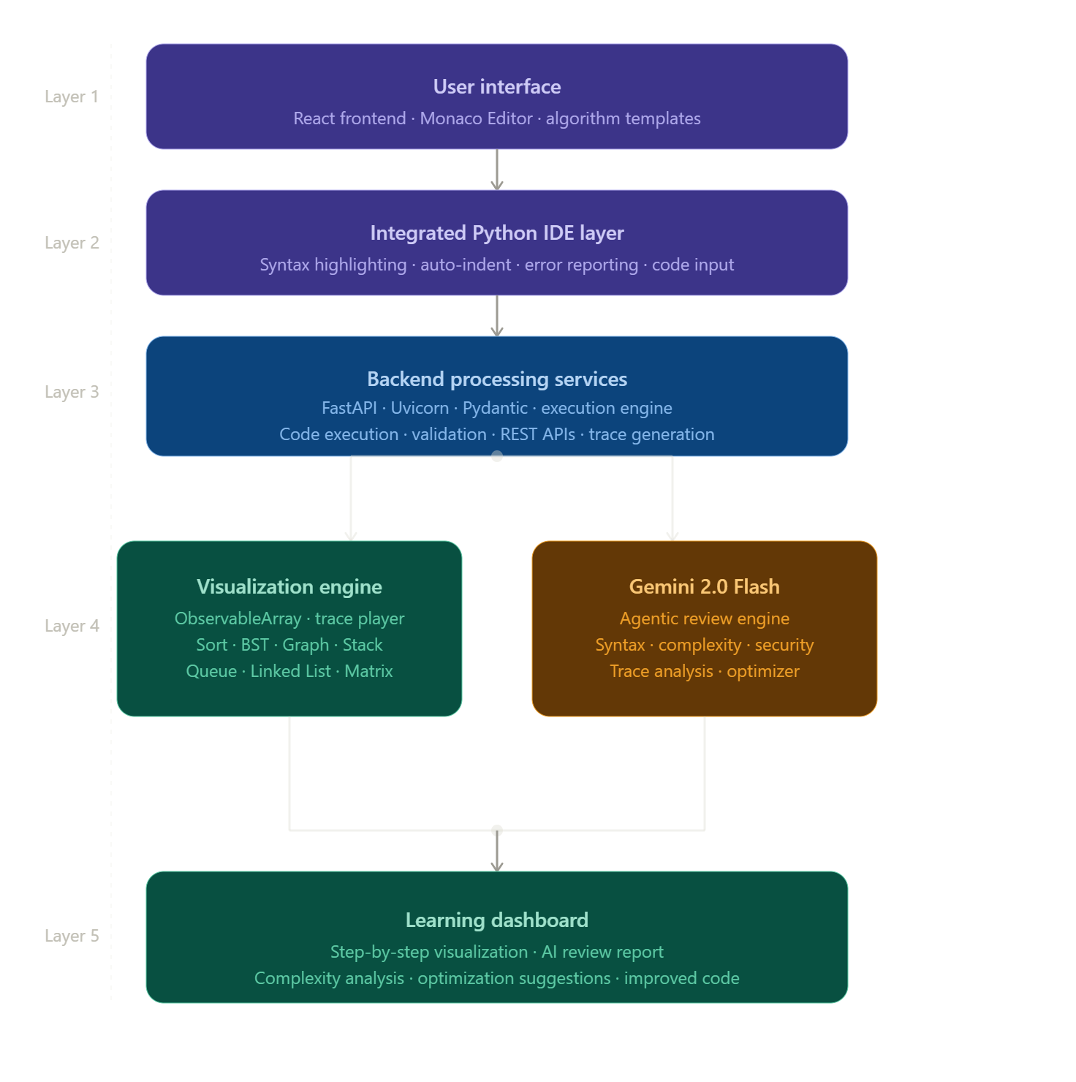

3.2 Module Decomposition and Responsibilities
The proposed AI-Powered Interactive Data Structures and Algorithms Visualizer with Integrated Python IDE follows a modular architecture in which each subsystem performs a specific set of responsibilities. Modular decomposition improves maintainability, scalability, testing efficiency, and future extensibility by separating system functionalities into independent components.
The system is divided into six major modules:
3.2.1 User Interface Module
The User Interface Module serves as the interaction layer between users and the system. It is developed using React.js and provides an intuitive, responsive, and interactive environment for learners.
Responsibilities:
• Display the integrated Python IDE
• Provide user-friendly navigation
• Accept user inputs and algorithm parameters
• Display visualization outputs
• Present AI-generated explanations
• Display complexity analysis results
• Manage user interactions and controls
Inputs:
• User code
• Custom input values
• User actions
Outputs:
• Visualization interface
• Execution results
• AI-generated educational insights
3.2.2 Code Execution Module
The Code Execution Module is responsible for processing and executing Python code submitted by users. It acts as the bridge between the frontend interface and backend services.
Responsibilities:
• Receive user code
• Validate code syntax
• Execute Python programs
• Capture execution outputs
• Generate execution states
• Handle runtime errors
Inputs:
• Python source code
• User-defined inputs
Outputs:
• Program output
• Execution states
• Error messages
3.2.3 Visualization Module
The Visualization Module converts execution states into graphical representations that help users understand algorithm behavior and data manipulation processes.
Responsibilities:
• Generate real-time visualizations
• Display algorithm execution steps
• Render supported data structures
• Animate state transitions
• Support visualization controls
• Update graphical components dynamically
Supported Components:
• Arrays
• Linked Lists
• Stacks
• Queues
• Trees
• Graphs
• Sorting Algorithms
• Searching Algorithms
• Traversal Algorithms
Inputs:
• Execution state data
Outputs:
• Interactive visualizations
• Animated execution flow
3.2.4 Artificial Intelligence Analysis Module
The Artificial Intelligence Analysis Module integrates Google Gemini 2.0 Flash to provide educational assistance and intelligent code analysis.
Responsibilities:
• Analyze source code
• Explain algorithm logic
• Identify implemented algorithms
• Generate complexity analysis
• Detect coding issues
• Suggest optimizations
• Provide educational guidance
Inputs:
• User-submitted code
Outputs:
• Algorithm explanations
• Complexity estimates
• Debugging suggestions
• Optimization recommendations
3.2.5 API Communication Module
The API Communication Module manages communication between the platform and external AI services.
Responsibilities:
• Send analysis requests
• Manage API interactions
• Handle request formatting
• Process API responses
• Handle communication failures
• Ensure reliable data transfer
Inputs:
• Code analysis requests
Outputs:
• Structured AI responses
• Error handling messages
3.2.6 Data Management and Processing Module
The Data Management Module coordinates data flow between frontend components, backend services, visualization modules, and AI services.
Responsibilities:
• Manage execution data
• Process user requests
• Store temporary execution states
• Coordinate module interactions
• Format responses
• Ensure data consistency
Inputs:
• User requests
• Execution outputs
• AI responses
Outputs:
• Structured data for visualization
• Processed results
• Learning dashboard information
Module Interaction Overview
The modules operate collaboratively to provide a seamless educational experience. The User Interface Module collects user code and forwards it to the Code Execution Module. The execution engine generates outputs and execution states that are sent to the Visualization Module. Simultaneously, the code is forwarded through the API Communication Module to the Artificial Intelligence Analysis Module powered by Gemini 2.0 Flash. The generated explanations, complexity analyses, and optimization suggestions are returned to the User Interface Module and displayed alongside the visualization outputs.
This modular design improves maintainability, simplifies future upgrades, and supports the integration of additional algorithms, programming languages, visualization techniques, and AI-powered educational features.
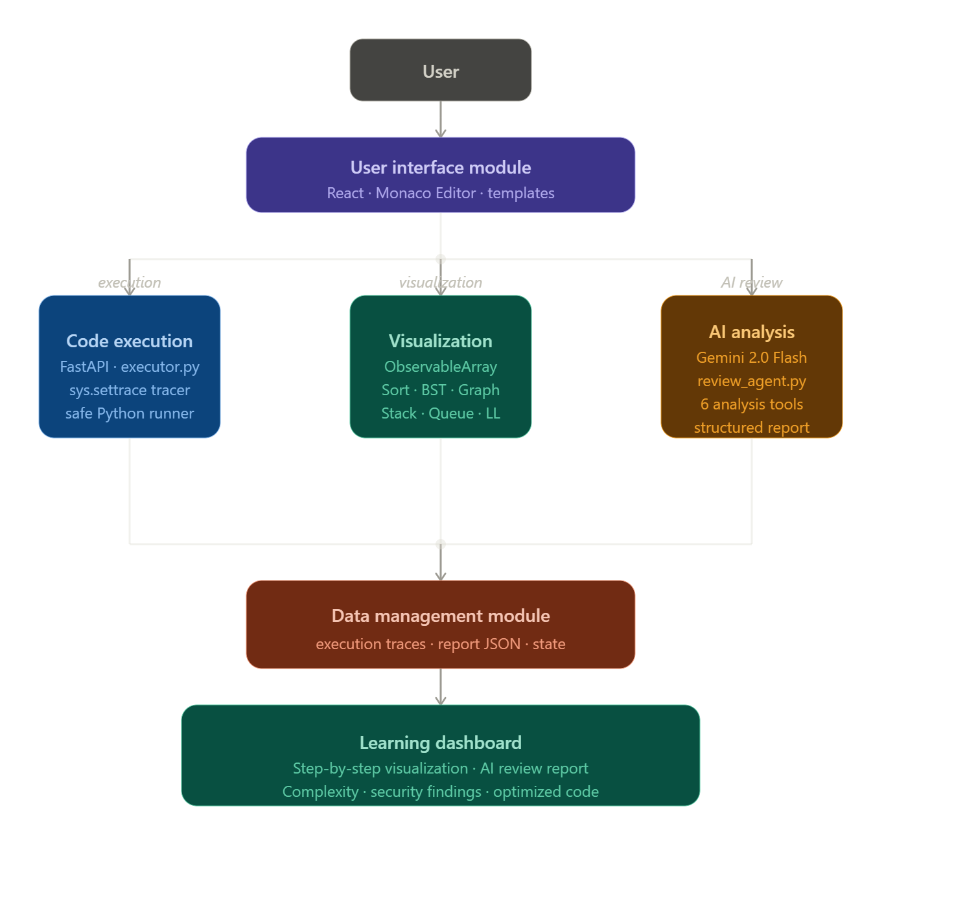

3.3 Sequence Diagram
A Sequence Diagram illustrates the chronological interaction between different components of the system during the execution of a particular process. It focuses on the order of communication between users, frontend components, backend services, visualization modules, and Artificial Intelligence services.
In the proposed AI-Powered Interactive Data Structures and Algorithms Visualizer with Integrated Python IDE, the sequence of interactions begins when a user submits Python code through the integrated IDE. The system then processes the code, generates execution states, creates visualizations, and simultaneously requests AI-powered analysis from Google Gemini 2.0 Flash.
The sequence diagram helps demonstrate how multiple system components collaborate to provide an interactive learning experience.
Actors and Components Involved:
• User
• React Frontend
• Python Execution Engine
• Visualization Engine
• API Communication Module
• Gemini 2.0 Flash AI Service
• Learning Dashboard
Workflow Description
Step 1:
The user writes or pastes Python code into the integrated IDE and initiates execution by clicking the Run button.
Step 2:
The frontend sends the source code and input parameters to the backend execution engine.
Step 3:
The backend validates and executes the submitted code.
Step 4:
Execution results and algorithm state information are generated.
Step 5:
The execution state data is forwarded to the visualization engine.
Step 6:
The visualization engine converts execution states into graphical representations and animations.
Step 7:
Simultaneously, the submitted code is forwarded to the AI analysis service through the API communication module.
Step 8:
Google Gemini 2.0 Flash analyzes the code and generates:
• Algorithm explanations
• Complexity analysis
• Debugging suggestions
• Optimization recommendations
Step 9:
The AI-generated educational insights are returned to the backend.
Step 10:
The frontend combines visualization outputs, execution results, and AI-generated responses.
Step 11:
The Learning Dashboard presents all information to the user through a unified interface.
The sequence of interactions ensures that users receive both visual and conceptual understanding of algorithm execution, making the learning experience more effective and interactive.
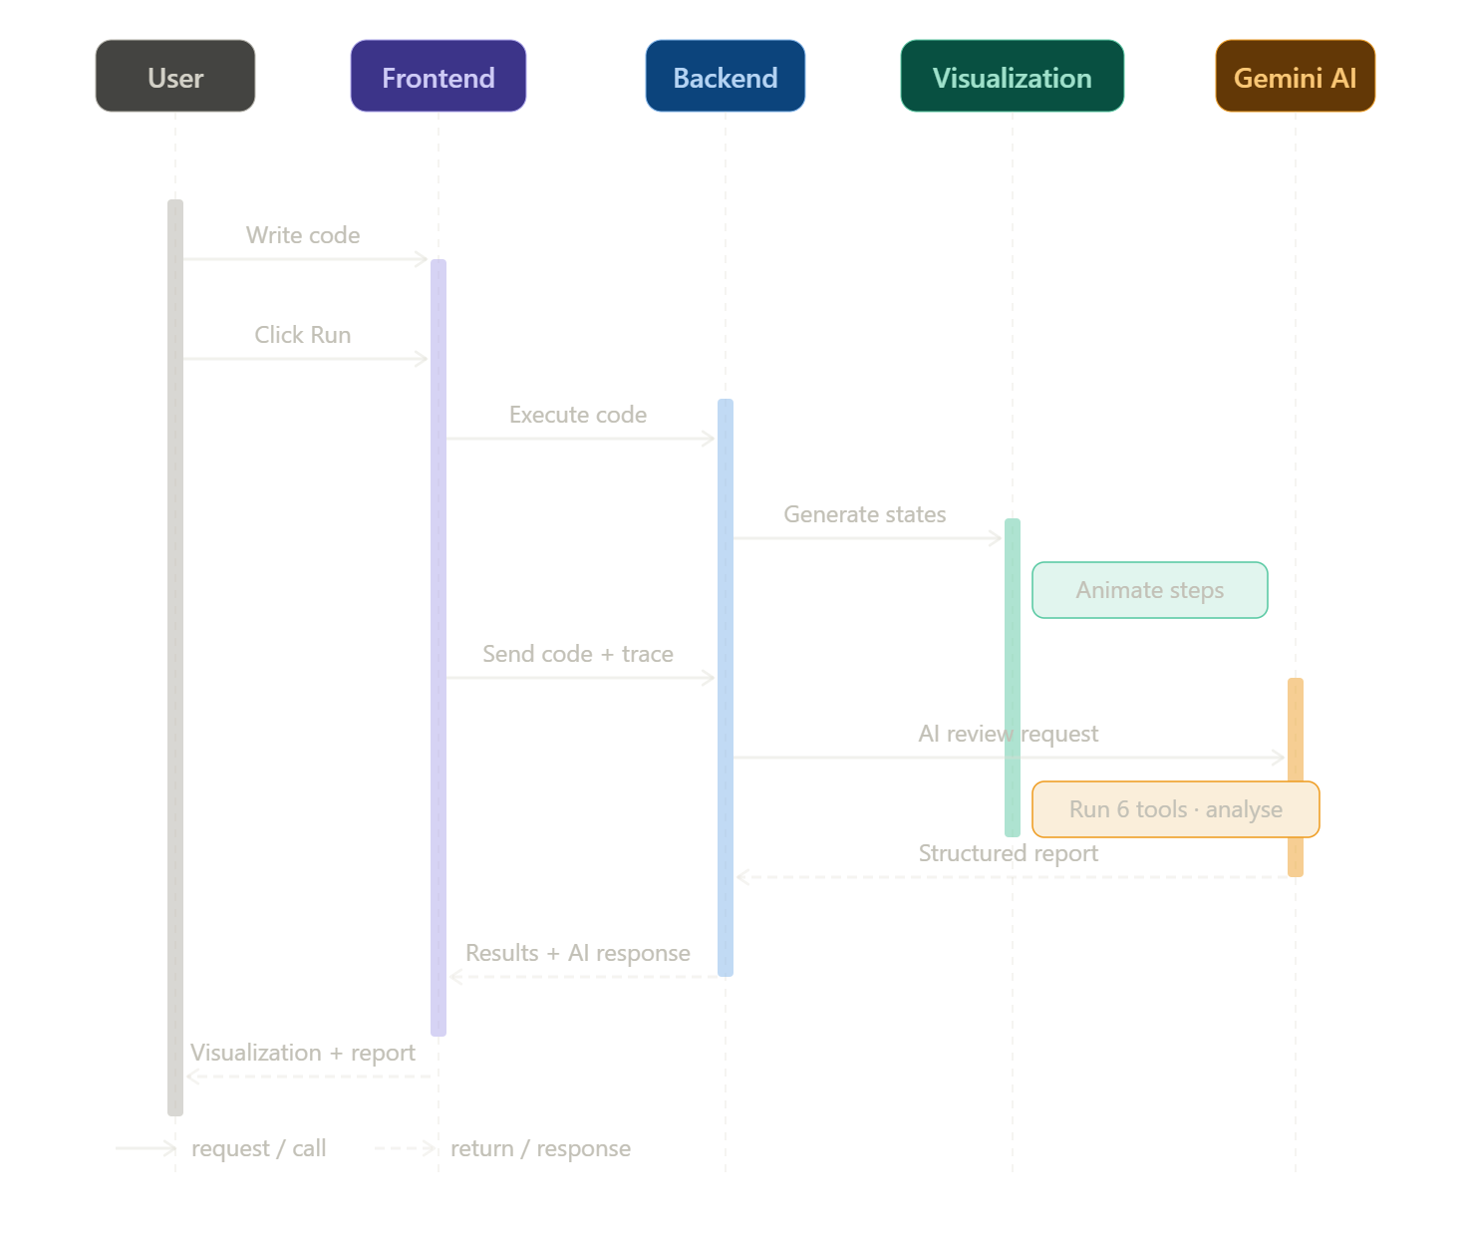

3.4 Data Flow Diagram (DFD)
A Data Flow Diagram (DFD) is a graphical representation used to illustrate the movement of data between different components of a system. It helps visualize how information is processed, transformed, and transferred throughout the application.
For the proposed AI-Powered Interactive Data Structures and Algorithms Visualizer with Integrated Python IDE, the DFD demonstrates how user code flows through the execution engine, visualization module, and Artificial Intelligence analysis services before being presented through the learning dashboard.
The DFD is divided into two levels:
• Level 0 DFD (Context Diagram)
• Level 1 DFD (Detailed System Flow)
3.4.1 Level 0 DFD (Context Diagram)
The Level 0 DFD provides a high-level overview of the entire system and its interaction with external entities.
External Entity:
• User
Main System:
• AI-Powered Interactive DSA Visualizer Platform
Data Flows:
• Source Code
• User Inputs
• Visualization Requests
• AI Analysis Requests
• Execution Results
• Learning Insights
The context diagram treats the entire platform as a single process and focuses only on the interaction between the user and the system.
3.4.2 Level 1 DFD
The Level 1 DFD expands the internal processes of the system and shows how data moves between major modules.
The primary processes include:
Process 1:
Code Submission and Input Handling
Process 2:
Code Execution Engine
Process 3:
Visualization Generation
Process 4:
AI Analysis Service
Process 5:
Learning Dashboard
The workflow begins when a user submits Python code through the integrated IDE. The code is validated and processed by the execution engine. Execution states are generated and forwarded to the visualization module. Simultaneously, the code is sent to Google Gemini 2.0 Flash for intelligent analysis. The generated explanations, complexity evaluations, debugging recommendations, and visualization outputs are then combined and presented through the learning dashboard.
The DFD helps illustrate how the system integrates execution, visualization, and AI-assisted learning into a unified educational workflow.
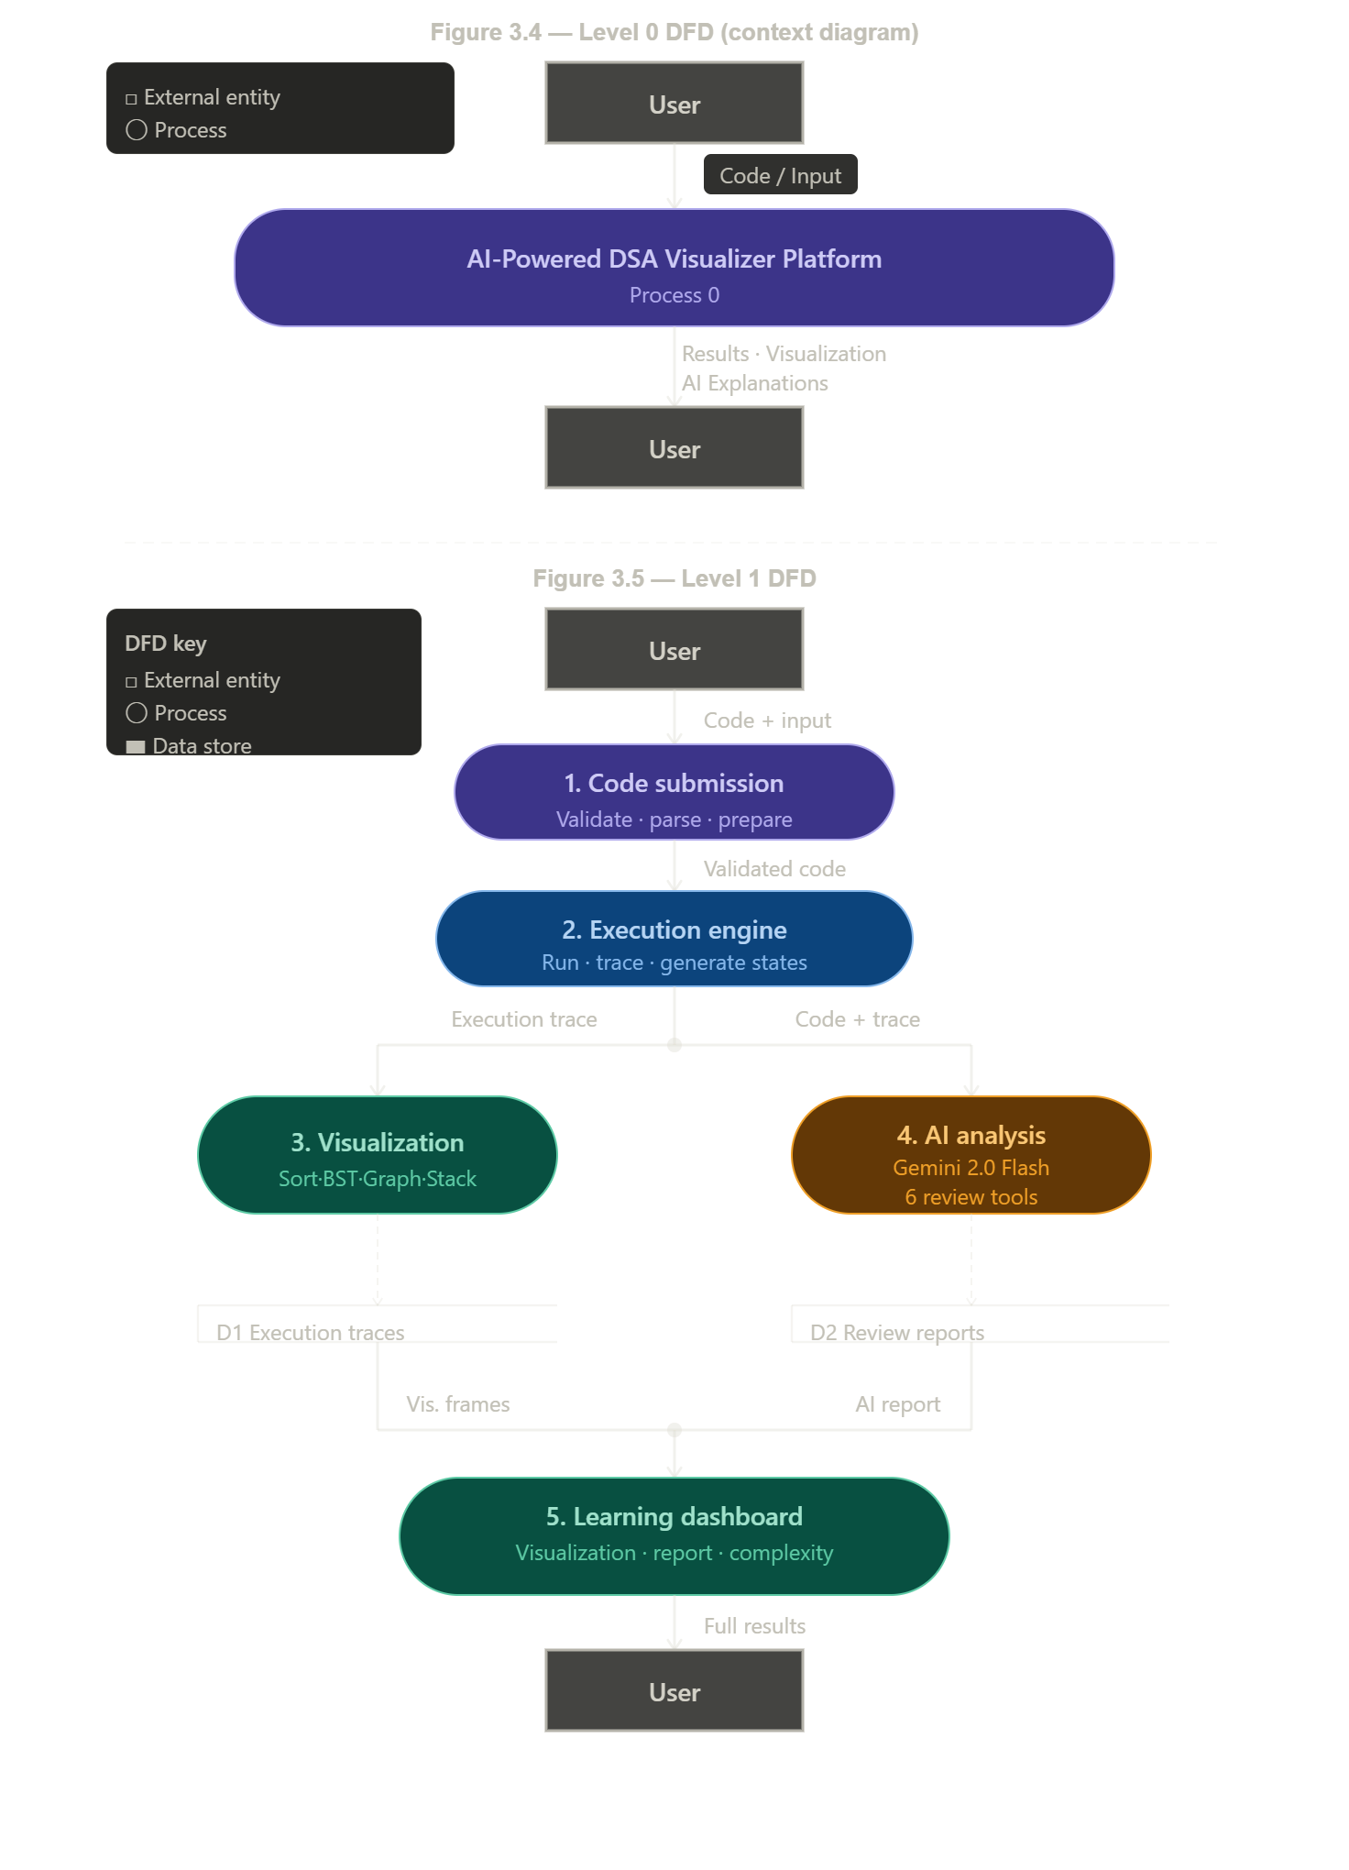
3.5 Data Management Design
The proposed AI-Powered Interactive Data Structures and Algorithms Visualizer with Integrated Python IDE does not rely on a traditional database management system for its core functionality. Since the primary objective of the platform is to provide real-time code execution, algorithm visualization, and AI-assisted learning, most data is processed dynamically during active user sessions rather than being permanently stored.
The system follows a transient data processing approach in which user-submitted code, execution states, visualization data, and AI-generated responses are handled temporarily during runtime. This approach simplifies system architecture, reduces storage requirements, and improves operational efficiency for educational use cases.
The data management design focuses on three major categories of information:
• User Input Data
• Execution State Data
• AI Analysis Data
The frontend collects Python source code and user-defined inputs through the integrated IDE. These inputs are transmitted to backend services where code execution and processing occur. During execution, temporary execution states are generated and forwarded to the visualization engine for graphical representation.
Simultaneously, the submitted code is sent to Google Gemini 2.0 Flash for intelligent analysis. The generated explanations, complexity evaluations, debugging recommendations, and optimization suggestions are processed and displayed to the user without long-term storage.
The temporary processing model ensures that the system remains lightweight, scalable, and focused on educational interactions rather than persistent data management.
3.5.1 Data Flow Management
The system manages data through a sequential processing pipeline:
User submits Python code and input values.
Backend services validate and execute the code.
Execution states are generated during runtime.
Visualization data is created from execution states.
Code is forwarded to Gemini 2.0 Flash for analysis.
AI-generated insights are returned to the system.
Visualization results and AI responses are displayed through the learning dashboard.
Since the information is processed temporarily, data remains available only during the active user session unless explicitly exported by future platform enhancements.
3.5.2 Temporary Data Architecture
The temporary data architecture consists of:
• Code Input Buffer
• Execution State Manager
• Visualization Data Generator
• AI Response Processor
• Learning Dashboard Renderer
These components collectively manage the flow of information throughout the system without requiring permanent storage mechanisms.
Advantages of Temporary Data Management
• Reduced system complexity
• Faster processing and response times
• Lower infrastructure requirements
• Improved maintainability
• Simplified deployment architecture
• Enhanced privacy due to limited data retention
The adopted data management strategy aligns with the educational objectives of the platform by prioritizing real-time interaction, visualization, and learning support over persistent data storage.
3.6 User Interface Design
The User Interface (UI) plays a critical role in determining the effectiveness and usability of an educational platform. The proposed AI-Powered Interactive Data Structures and Algorithms Visualizer with Integrated Python IDE is designed with a focus on simplicity, accessibility, responsiveness, and educational effectiveness. The interface allows users to seamlessly interact with coding, visualization, and Artificial Intelligence based learning features through a unified workspace.
The design philosophy of the platform emphasizes minimizing distractions while maximizing learning efficiency. Instead of separating coding, execution, visualization, and explanation into different pages, the platform integrates all major functionalities into a single interactive environment.
3.6.1 Design Objectives
The primary objectives of the user interface design are:
• Provide an intuitive coding environment.
• Simplify algorithm experimentation.
• Improve visualization accessibility.
• Enable seamless AI interaction.
• Reduce learning complexity.
• Support responsive web-based access.
• Enhance educational engagement.
The interface is designed to accommodate both beginners and advanced learners by presenting information in a structured and easy-to-understand format.
3.6.2 Main Interface Components
Integrated Python IDE
The Integrated Python IDE serves as the central workspace of the platform. Users can write, edit, and execute Python code directly within the browser. The editor supports a clean coding environment that encourages experimentation and learning.
Major Functions:
• Writing Python programs
• Editing source code
• Algorithm implementation
• Code testing
• Learning through experimentation
Input Panel
The input panel allows users to provide custom data for algorithm execution. Users can enter arrays, graph structures, search values, or other algorithm-specific parameters.
Major Functions:
• Custom test case creation
• Input modification
• Experimentation with different datasets
Execution Controls
Execution controls allow users to manage code execution and visualization behavior.
Major Functions:
• Run code
• Pause visualization
• Resume visualization
• Reset execution
• Control animation speed
Visualization Workspace
The visualization workspace displays graphical representations of algorithm execution. It converts execution states into dynamic visual elements that help learners understand internal operations and execution flow.
Major Functions:
• Real-time visualization
• Data structure rendering
• Step-by-step algorithm animation
• Execution tracking
AI Learning Assistant Panel
The AI Learning Assistant Panel displays educational insights generated by Google Gemini 2.0 Flash. This component transforms the platform into an intelligent learning environment by providing contextual explanations and guidance.
Major Functions:
• Algorithm explanation
• Complexity analysis
• Debugging support
• Optimization suggestions
• Educational guidance
Output Console
The output console displays program execution results and runtime information generated by the backend execution engine.
Major Functions:
• Program output display
• Error messages
• Execution feedback
• Runtime information
3.6.3 User Interaction Workflow
The user interaction workflow follows a simple and educationally effective sequence:
User writes Python code in the IDE.
User provides custom input values.
User executes the program.
Backend services process the code.
Visualization engine generates graphical representations.
Gemini 2.0 Flash analyzes the submitted code.
AI-generated insights are produced.
Results are displayed through the learning dashboard.
This workflow allows learners to simultaneously observe algorithm execution, understand implementation logic, and receive educational feedback.
3.6.4 Design Principles
The interface design follows several important principles:
• Simplicity
• Consistency
• Responsiveness
• Accessibility
• Educational effectiveness
• User-centered design
• Minimal cognitive load
These principles ensure that users remain focused on learning rather than navigating complex interfaces.
The user interface therefore acts as the central component that integrates coding, visualization, and Artificial Intelligence assistance into a unified educational experience, making the learning of Data Structures and Algorithms more interactive, intuitive, and engaging.
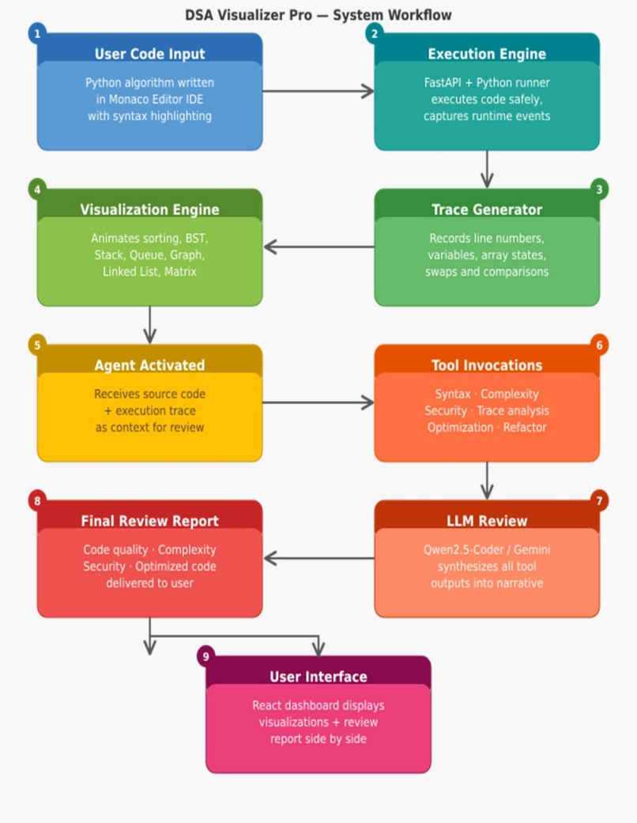

3.7 System Workflow
The system workflow describes the complete operational sequence followed by the AI-Powered Interactive Data Structures and Algorithms Visualizer with Integrated Python IDE. The workflow illustrates how user inputs are processed, visualized, analyzed, and presented through the platform.
The workflow begins when a user accesses the platform and writes Python code inside the integrated IDE. The user may either implement a supported data structure, create an algorithm, or paste an existing solution for analysis and visualization.
Once the code is prepared, the user provides any required input values and initiates execution using the Run functionality. The submitted code is transmitted to the backend execution engine, where syntax validation and runtime processing are performed.
During execution, the backend generates execution states representing important algorithm operations and data transitions. These execution states are forwarded to the visualization module, which converts them into graphical representations and animations. The generated visualizations enable users to observe the internal behavior of algorithms and data structures step-by-step.
Simultaneously, the submitted source code is sent to Google Gemini 2.0 Flash through the API communication layer. The AI service analyzes the code and generates educational insights including algorithm explanations, complexity evaluations, debugging recommendations, and optimization suggestions.
The responses generated by the AI service are returned to the backend and combined with execution outputs and visualization results. The frontend then presents all information through a unified learning dashboard.
The final output provided to the user includes:
• Program execution output
• Real-time visualization
• Algorithm explanation
• Time complexity analysis
• Space complexity analysis
• Debugging guidance
• Optimization recommendations
This workflow enables learners to understand not only what an algorithm produces but also how it operates internally and why certain implementation decisions affect performance and efficiency.
The integration of coding, visualization, and Artificial Intelligence creates a complete learning environment that supports both conceptual understanding and practical implementation of Data Structures and Algorithms.
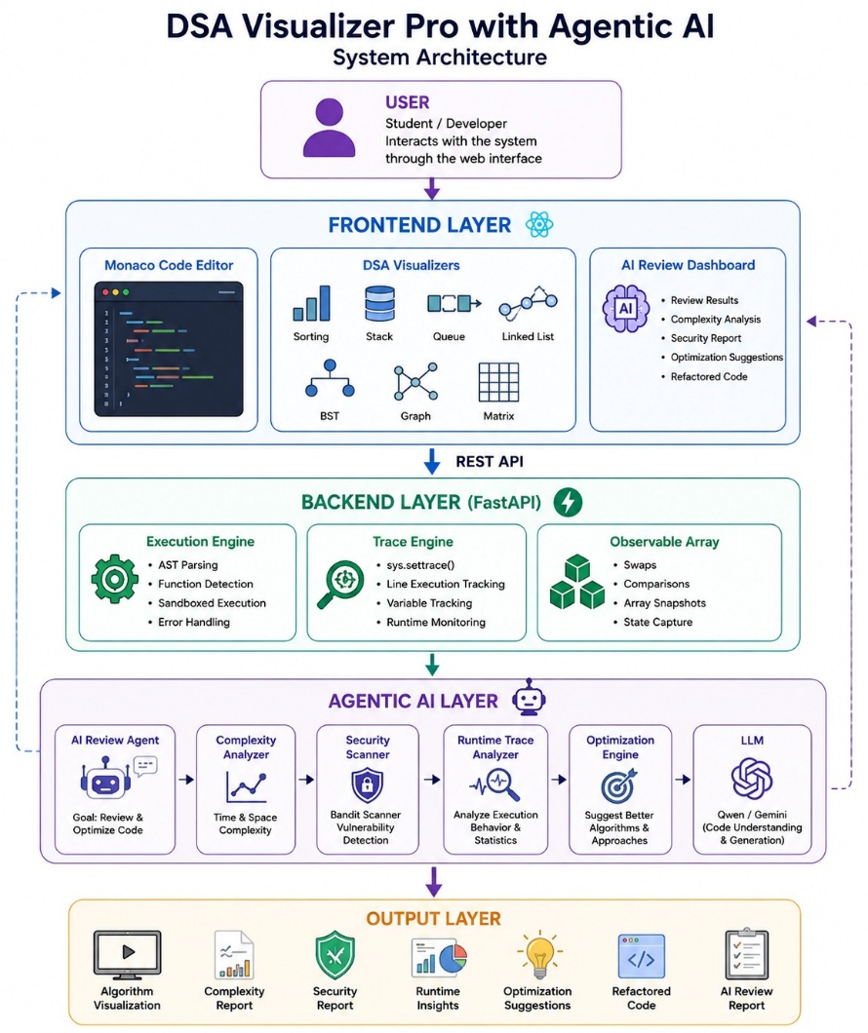

3.8 Chapter Summary
This chapter presented the analysis, design, and technical architecture of the proposed AI-Powered Interactive Data Structures and Algorithms Visualizer with Integrated Python IDE. The chapter described the overall system architecture, module decomposition, sequence diagrams, data flow diagrams, data management design, user interface design, and system workflow.
The analysis demonstrated how frontend components, backend execution services, visualization modules, and Google Gemini 2.0 Flash collaborate to provide an integrated educational platform. The modular architecture ensures maintainability, scalability, and future extensibility while supporting real-time code execution, visualization, and AI-assisted learning.
The design presented in this chapter serves as the foundation for the implementation phase discussed in the next chapter. The following chapter focuses on the technologies used, implementation methodology, testing procedures, and practical realization of the proposed system.

CHAPTER 4

IMPLEMENTATION, TESTING & RESULTS

4.1 Introduction
The implementation phase transforms the system design and architectural specifications into a functional software solution. This chapter describes the practical realization of the proposed AI-Powered Interactive Data Structures and Algorithms Visualizer with Integrated Python IDE. The implementation focuses on integrating code execution, algorithm visualization, and Artificial Intelligence powered educational assistance into a unified learning environment.
The system was developed using modern web technologies and follows a modular architecture to ensure maintainability, scalability, and ease of future enhancement. React.js was used for developing the frontend interface, while Python was utilized for backend processing and execution management. Google Gemini 2.0 Flash was integrated to provide intelligent code analysis, algorithm explanations, complexity evaluation, debugging support, and optimization recommendations.
This chapter presents the technologies used during development, implementation details of individual modules, testing procedures, and evaluation results obtained from the completed prototype.

4.2 Technology Stack
Layer | Technology Used
Frontend | React.js
Programming Language | JavaScript
Backend | Python
AI Engine | Gemini 2.0 Flash
API Communication | REST APIs
Styling | CSS / Tailwind CSS
IDE Component | Monaco Editor
Version Control | Git & GitHub
Development Environment | Visual Studio Code
Browser Support | Chrome, Edge, Firefox

4.3 Development Environment
The development of the AI-Powered Interactive Data Structures and Algorithms Visualizer with Integrated Python IDE was carried out using a modern web development environment that supports rapid prototyping, modular development, and efficient debugging.
The frontend application was developed using React.js and Vite. React provided a component-based architecture that simplified user interface development, while Vite offered fast build times and Hot Module Replacement (HMR) capabilities for efficient development and testing.
Visual Studio Code was used as the primary Integrated Development Environment (IDE) due to its extensive support for JavaScript, Python, React development, debugging tools, and extension ecosystem.
The backend services were implemented using Python and FastAPI. FastAPI was selected because of its high performance, automatic API documentation generation, and compatibility with asynchronous programming models. Uvicorn was used as the ASGI server to run backend services during development and testing.
Google Gemini 2.5 Flash was integrated through the official google-genai SDK. API credentials and environment configurations were securely managed using python-dotenv and environment variables stored in local configuration files.
Version control and source code management were performed using Git and GitHub, enabling systematic tracking of development progress and project modifications.
Table 4.1 Development Environment
Component | Technology
Operating System | Windows 10/11
Frontend Framework | React 18.3
Build Tool | Vite 5.3
Backend Framework | FastAPI
Backend Language | Python 3
API Server | Uvicorn
AI SDK | google-genai
AI Model | Gemini 2.5 Flash
Environment Management | python-dotenv
Source Code Editor | Visual Studio Code
Version Control | Git & GitHub
Browser Testing | Chrome, Edge, Firefox

4.4 System Implementation
The implementation phase focused on transforming the system architecture into a fully functional educational platform. The developed prototype integrates an interactive coding environment, execution engine, algorithm visualization system, and AI-powered code review assistant into a unified web application.
The implementation follows a modular architecture where each subsystem performs a dedicated role while communicating through APIs and structured data exchange mechanisms.
The major implementation modules are described below.
4.4.1 Frontend Implementation
The frontend application was developed using React.js and Vite. The user interface follows a component-based architecture that promotes code reusability, maintainability, and scalability.
The platform adopts an IDE-first design approach where users are immediately presented with a coding workspace upon accessing the application.
Key frontend features include:
• Integrated code editor
• Input management interface
• Execution controls
• Visualization workspace
• AI analysis panel
• Output console
• Light and dark theme support
The Monaco Editor package was integrated to provide a professional coding experience similar to Visual Studio Code. Features such as syntax highlighting, automatic indentation, code formatting, and intelligent editing capabilities improve usability and learning effectiveness.
Custom CSS3 was utilized for interface styling. Flexbox and CSS Grid were employed to create responsive layouts, while CSS animations were implemented to visually represent algorithm operations and execution transitions.
The frontend communicates with backend services through REST APIs and dynamically updates interface components based on execution and analysis results.
4.4.2 Backend Implementation
The backend services were implemented using Python and FastAPI. The backend acts as the central processing layer responsible for code execution, execution state generation, AI integration, and data processing.
FastAPI was selected because of its high performance, asynchronous capabilities, automatic API documentation, and strong support for data validation through Pydantic models.
Major backend responsibilities include:
• Receiving user code submissions
• Input validation
• Code execution management
• Execution trace generation
• Visualization data preparation
• AI request processing
• Error handling and response generation
Pydantic models were used to validate incoming requests and ensure data consistency throughout the system.
The backend exposes REST API endpoints that allow the frontend to submit code, request visualizations, and obtain AI-generated educational insights.
Uvicorn serves as the ASGI server responsible for hosting and running backend services during development and testing.
4.4.3 Visualization Engine Implementation
The Visualization Engine is responsible for transforming algorithm execution states into graphical representations that help learners understand the internal behavior of Data Structures and Algorithms.
The implementation utilizes Python Abstract Syntax Trees (AST) and execution tracing mechanisms to monitor program execution and capture algorithm state transitions.
The system employs the following technologies:
• Python AST (Abstract Syntax Tree)
• sys.settrace Execution Tracing
• React-based Rendering Components
• Custom Animation Framework
The AST parser analyzes source code structure and identifies algorithmic operations such as comparisons, assignments, insertions, deletions, and swaps.
The execution tracing system records runtime events and generates structured execution states. These states are transmitted to the frontend where visualization components convert them into graphical animations.
Supported visualization categories include:
• Arrays
• Searching Algorithms
• Sorting Algorithms
• Data Manipulation Operations
• Step-by-Step Execution States
Custom animation mechanisms were developed using CSS keyframes and React state management techniques. Visual effects such as element highlighting, movement animations, swap operations, and execution indicators improve learner understanding and engagement.
The visualization engine forms one of the core educational components of the platform by converting abstract algorithm behavior into interactive visual experiences.
4.4.4 AI Integration Module
Artificial Intelligence functionality is implemented using Google's Gemini family of Large Language Models through the official google-genai SDK.
The primary AI model used in the system is Gemini 2.5 Flash. To improve reliability and service availability, fallback mechanisms automatically switch to Gemini 2.5 Flash Lite and Gemini Flash Lite Latest whenever primary model access becomes unavailable or rate-limited.
The AI module performs educational analysis of user-submitted code and generates structured learning-oriented responses.
Major AI functionalities include:
• Algorithm explanation
• Code quality assessment
• Time complexity analysis
• Space complexity analysis
• Debugging assistance
• Optimization recommendations
• Educational guidance
When a user requests AI analysis, the submitted code is forwarded to Gemini through the backend service layer. The generated response is processed and converted into a structured educational report before being displayed within the interface.
This AI-assisted learning mechanism transforms the platform from a traditional visualization tool into an intelligent educational environment capable of providing personalized guidance and code review support.
The integration of Gemini significantly enhances learner understanding by explaining not only how algorithms work but also how implementations can be improved for efficiency, readability, and maintainability.

- 4.5 User Interface Screens
Insert screenshots from your project and use these descriptions below each figure.

- Figure 4.1 Main IDE Interface
Description:
Figure 4.1 illustrates the main interface of the AI-Powered Interactive Data Structures and Algorithms Visualizer. Upon accessing the platform, users are presented directly with an integrated Python development environment based on Monaco Editor. The interface provides a distraction-free coding workspace where users can write, edit, and execute Python programs. This IDE-first design eliminates unnecessary navigation and allows learners to immediately begin experimenting with algorithms and data structures.

- Figure 4.2 Code Execution Interface
Description:
Figure 4.2 shows the code execution interface after a user submits a Python program. The backend FastAPI service processes the code and returns execution results. The interface displays program output, execution status, and runtime information. Any syntax or runtime errors are presented clearly to assist learners in identifying and correcting mistakes.

- Figure 4.3 Algorithm Visualization Interface
Description:
Figure 4.3 presents the visualization module responsible for displaying algorithm execution behavior. Execution states generated through Python AST analysis and tracing mechanisms are transformed into graphical animations. The visualization enables learners to observe operations such as comparisons, swaps, insertions, and data movement in a step-by-step manner, improving conceptual understanding of algorithm behavior.

- Figure 4.4 AI Analysis Dashboard
Description:
Figure 4.4 illustrates the Artificial Intelligence analysis dashboard powered by Gemini 2.5 Flash. The dashboard provides educational insights including algorithm explanations, implementation reviews, code quality assessments, and conceptual guidance. The AI module functions as an intelligent learning assistant that helps users understand both theoretical and practical aspects of algorithm implementation.

- Figure 4.5 Complexity Analysis Output
Description:
Figure 4.5 displays the complexity analysis generated by the AI engine. The system evaluates the submitted implementation and estimates both time complexity and space complexity. The generated analysis assists learners in understanding performance characteristics and encourages the development of efficient algorithmic solutions.

- Figure 4.6 Optimization Suggestions Interface
Description:
Figure 4.6 demonstrates the optimization recommendation module. After analyzing user code, Gemini generates improved implementations and performance-enhancing suggestions. The optimized code is displayed within a dedicated Monaco Editor instance, enabling users to compare their original implementation with AI-generated recommendations and learn best coding practices.

- 4.6 Testing Methodology
Use this next:
- 4.6 Testing Methodology
The testing phase was conducted to verify the correctness, reliability, performance, and usability of the proposed system. Multiple testing techniques were employed to ensure that all major functionalities operated according to the specified requirements.
The testing process focused on the following areas:
- Frontend functionality testing
- Backend API testing
- Visualization accuracy testing
- AI integration testing
- Error handling testing
- User interface testing
The testing approach primarily followed Black Box Testing, where system outputs were evaluated against expected behavior without considering internal implementation details.
The major objectives of testing were:
- Verify correct code execution.
- Validate visualization generation.
- Ensure proper AI response generation.
- Detect and handle invalid user inputs.
- Evaluate system responsiveness.
- Verify integration between modules.

- 4.7 Test Cases and Results
The developed system was tested using multiple functional and integration test cases to verify the correctness of code execution, visualization generation, Artificial Intelligence analysis, and overall system behavior. The testing process ensured that all core modules operated according to the defined requirements.
The results obtained during testing demonstrate that the platform successfully performs code execution, algorithm visualization, complexity analysis, debugging assistance, and optimization recommendation generation.
- Table 4.2 Functional Test Cases
Test Case ID | Test Scenario | Input | Expected Result | Actual Result | Status
TC-01 | Python Code Execution | Valid Python Program | Program executes successfully and output is displayed | Output displayed correctly | Pass
TC-02 | Syntax Error Detection | Python code with syntax error | Error message displayed | Error identified correctly | Pass
TC-03 | Runtime Error Handling | Division by zero program | Runtime error displayed | Error handled correctly | Pass
TC-04 | Visualization Generation | Bubble Sort implementation | Visualization generated | Visualization displayed correctly | Pass
TC-05 | Execution State Tracking | Sorting algorithm | Step-by-step states generated | States generated correctly | Pass
TC-06 | AI Code Analysis | Python sorting code | AI explanation generated | Explanation generated successfully | Pass
TC-07 | Complexity Analysis | Algorithm implementation | Time and space complexity displayed | Complexity generated correctly | Pass
TC-08 | Optimization Suggestions | Inefficient code | Optimized solution suggested | Suggestions generated successfully | Pass
TC-09 | User Interface Responsiveness | Multiple screen sizes | Responsive layout maintained | Responsive behavior verified | Pass
TC-10 | API Communication | AI request submission | Successful API response | Response received successfully | Pass

- Table 4.3 Integration Testing Results
Module Interaction | Expected Outcome | Result
Frontend ↔ Backend | Successful code submission and response generation | Successful
Backend ↔ Visualization Engine | Execution states generated correctly | Successful
Backend ↔ Gemini API | AI analysis returned successfully | Successful
Visualization ↔ Dashboard | Graphical output displayed correctly | Successful
AI Module ↔ Dashboard | Educational insights displayed correctly | Successful

- Error Handling Testing
The system was evaluated using invalid and unexpected inputs to verify robustness and reliability.
- Table 4.4 Error Handling Test Results
Test Scenario | Expected Behavior | Result
Empty Code Submission | Warning message displayed | Pass
Invalid Python Syntax | Syntax error identified | Pass
Runtime Exception | Error message generated | Pass
Unsupported Algorithm | Appropriate notification displayed | Pass
AI Service Unavailable | Graceful fallback message shown | Pass

- Testing Summary
The testing results indicate that all major system functionalities operate successfully. Code execution, visualization generation, AI-powered analysis, debugging assistance, and optimization recommendations were produced accurately under normal operating conditions. Error handling mechanisms also demonstrated reliable behavior when invalid inputs were supplied.
The successful completion of testing confirms that the developed prototype satisfies its intended educational objectives and provides a stable environment for learning Data Structures and Algorithms.

- Next Section: 4.8 Performance Evaluation
Use this section:
- 4.8 Performance Evaluation
Performance evaluation was conducted to assess the responsiveness, efficiency, and reliability of the developed platform. The evaluation focused on execution performance, visualization generation speed, AI response time, and overall user experience.
The system was tested using various algorithm implementations including sorting, searching, and array manipulation programs.
- Table 4.5 Performance Evaluation Results
Parameter | Observation
IDE Loading Time | Less than 2 seconds
Code Execution Response | Instant for standard educational programs
Visualization Generation | Generated in real time
AI Analysis Response Time | Approximately 2–5 seconds depending on complexity
UI Responsiveness | Smooth and responsive
API Communication Reliability | Stable under normal usage
Error Detection Speed | Immediate
- Performance Discussion
The React and Vite frontend architecture provides fast rendering and smooth user interactions. FastAPI and Uvicorn deliver efficient backend processing with low response latency. The visualization engine successfully generates execution states and animations in real time, enabling interactive learning experiences.
Gemini 2.5 Flash provides high-quality educational insights with acceptable response times for academic use cases. Although AI analysis depends on internet connectivity and API availability, the observed performance was satisfactory during testing.
The performance evaluation demonstrates that the proposed platform effectively supports real-time code execution, visualization, and AI-assisted learning without noticeable delays during normal operation.

- 4.9 Results and Discussion
The developed AI-Powered Interactive Data Structures and Algorithms Visualizer with Integrated Python IDE was successfully implemented and tested according to the objectives defined during the requirement analysis phase. The completed prototype integrates coding, execution, visualization, and Artificial Intelligence assistance into a single educational platform.
The system allows users to write Python programs directly within the browser-based IDE and execute them without requiring external development tools. The execution engine successfully processes user code and generates outputs while simultaneously producing execution traces for visualization purposes.
The visualization module effectively converts algorithm execution states into graphical representations. This feature significantly improves conceptual understanding by allowing users to observe algorithm behavior step-by-step. Operations such as comparisons, swaps, insertions, and state transitions become easier to understand when represented visually rather than through textual output alone.
The integration of Google Gemini 2.5 Flash proved to be one of the most valuable components of the platform. The AI module successfully generated:
• Algorithm explanations
• Time complexity analysis
• Space complexity analysis
• Debugging assistance
• Code quality reviews
• Optimization recommendations
The generated explanations helped bridge the gap between theoretical concepts and practical implementation. Instead of merely displaying results, the system provided educational insights that improved learner understanding of algorithmic behavior and performance characteristics.
The use of Monaco Editor enhanced the coding experience by providing a professional development environment similar to Visual Studio Code. Features such as syntax highlighting, code formatting, and structured editing improved usability and user engagement.
Performance testing indicated that the frontend remained responsive during execution and visualization tasks. FastAPI and Uvicorn delivered efficient backend processing, while Gemini responses were generated within acceptable time limits for educational applications.
The completed prototype successfully achieved all major project objectives:
- Integrated coding environment
- Real-time code execution
- Interactive algorithm visualization
- AI-powered educational assistance
- Complexity analysis generation
- Code optimization support
- User-friendly learning experience
Overall, the results demonstrate that combining visualization technologies with Artificial Intelligence creates a more effective and engaging learning environment compared to traditional static learning methods.

- Table 4.6 Objective Achievement Analysis
Project Objective | Achievement Status
Integrated Python IDE | Achieved
Algorithm Visualization | Achieved
Real-Time Execution | Achieved
AI-Based Code Explanation | Achieved
Complexity Analysis | Achieved
Debugging Assistance | Achieved
Optimization Suggestions | Achieved
Educational Learning Support | Achieved
Interactive Learning Environment | Achieved

- 4.10 Chapter Summary
- 4.10 Chapter Summary
This chapter presented the implementation, testing, and evaluation of the AI-Powered Interactive Data Structures and Algorithms Visualizer with Integrated Python IDE. The technologies used during development, implementation details of individual modules, testing procedures, and performance evaluation results were discussed in detail.
The developed prototype successfully integrates code execution, algorithm visualization, and Artificial Intelligence based educational assistance into a unified learning platform. Testing results confirmed the correctness, reliability, and usability of the system, while performance evaluation demonstrated its suitability for educational applications.
The obtained results indicate that the platform effectively supports interactive learning of Data Structures and Algorithms through visualization and AI-assisted guidance. The next chapter presents the overall conclusions, project outcomes, limitations, and future enhancement opportunities.

CHAPTER 5

RESULTS, DATA ANALYSIS & DISCUSSION

- 5.1 Results and Data Analysis
The implementation and testing of the AI-Powered Interactive Data Structures and Algorithms Visualizer with Integrated Python IDE produced positive outcomes across all major functional areas. The developed system successfully combines code execution, algorithm visualization, and Artificial Intelligence based educational assistance within a unified learning platform.
The obtained results demonstrate that the proposed solution effectively addresses several limitations present in traditional learning methods, where learners often struggle to understand the internal behavior of algorithms and data structures through static code examples alone.
The platform enables users to:
• Write Python programs using an integrated browser-based IDE.
• Execute algorithms in real time.
• Observe step-by-step execution through visual representations.
• Receive AI-generated algorithm explanations.
• Analyze time and space complexity.
• Obtain debugging assistance.
• Receive optimization recommendations.
The integration of visualization and AI-generated educational insights significantly improves conceptual understanding by combining practical implementation with theoretical explanations.
The system was evaluated across multiple categories of Data Structures and Algorithms including:
• Sorting Algorithms
• Searching Algorithms
• Array Operations
• Iterative Algorithms
• Recursive Algorithms
• Data Manipulation Tasks
The generated visualizations accurately represented execution states and algorithm transitions, while Gemini 2.5 Flash consistently produced meaningful explanations and performance analyses.

- Table 5.1 Functional Outcome Analysis
Feature | Expected Outcome | Achieved Outcome
Code Execution | Successful execution of Python programs | Achieved
Visualization Generation | Interactive graphical representation | Achieved
Algorithm Explanation | AI-generated explanation | Achieved
Complexity Analysis | Time and space complexity generation | Achieved
Debugging Assistance | Error identification and guidance | Achieved
Optimization Suggestions | Improved implementation recommendations | Achieved
Educational Support | Enhanced learning experience | Achieved

- Educational Impact Analysis
The platform demonstrated significant educational value by improving learner engagement and understanding. Traditional learning approaches typically rely on textual explanations and static diagrams, whereas the developed system provides:
• Interactive learning experiences
• Immediate feedback
• Visual understanding of execution flow
• Personalized AI-generated explanations
• Improved debugging skills
• Better comprehension of algorithm efficiency
The combination of visualization and AI support creates a more effective learning environment compared to conventional educational resources.

- 5.2 Discussion
- 5.2 Discussion
The project demonstrates the potential of combining modern web technologies with Artificial Intelligence to enhance computer science education. By integrating coding, execution, visualization, and educational assistance into a single environment, the platform reduces the fragmentation commonly experienced when learners use multiple independent tools.
The visualization engine successfully addresses one of the most common challenges in learning Data Structures and Algorithms: understanding how algorithms manipulate data internally during execution. The generated animations make abstract concepts more concrete and easier to comprehend.
The integration of Gemini 2.5 Flash further extends the educational value of the system. Rather than functioning solely as a visualization tool, the platform acts as an intelligent learning assistant capable of explaining algorithm behavior, evaluating complexity, identifying issues, and recommending improvements.
The modular architecture adopted during development ensures maintainability and provides a strong foundation for future enhancements. New algorithms, visualizations, programming languages, and AI capabilities can be incorporated without major architectural modifications.
The results obtained during implementation and testing indicate that the proposed system successfully achieves its intended objectives while maintaining acceptable performance and usability standards.

- 5.3 Conclusion
- 5.3 Conclusion
The AI-Powered Interactive Data Structures and Algorithms Visualizer with Integrated Python IDE was successfully designed, developed, and evaluated as part of this project. The system integrates real-time code execution, algorithm visualization, and Artificial Intelligence based educational assistance into a unified web-based learning environment.
The project addresses several challenges faced by students while learning Data Structures and Algorithms, particularly the difficulty of understanding algorithm behavior through static code and theoretical explanations alone. By combining visual learning techniques with AI-generated insights, the platform provides a more interactive and effective educational experience.
The developed system successfully achieved all major project objectives, including:
• Development of an integrated browser-based Python IDE.
• Real-time code execution and output generation.
• Interactive visualization of algorithm execution.
• AI-generated explanations and educational guidance.
• Complexity analysis generation.
• Debugging support and optimization recommendations.
• Enhanced learner engagement and understanding.
Testing and evaluation confirmed that the system performs reliably and delivers meaningful educational value. The results demonstrate that integrating Artificial Intelligence with visualization technologies can significantly improve the learning experience for Data Structures and Algorithms.
Therefore, the proposed platform represents a practical and innovative educational tool capable of supporting students, self-learners, and educators in understanding fundamental algorithmic concepts more effectively.

- 5.4 Limitations of the Current System
- 5.4 Limitations of the Current System
Although the developed platform successfully achieves its primary objectives, several limitations exist in the current implementation:
• Support is currently limited to Python programming language.
• Visualization support is available only for selected algorithms and data structures.
• AI-assisted features require internet connectivity.
• Gemini API usage is subject to rate limits and service availability.
• Multi-user collaboration functionality is not currently implemented.
• Persistent storage and user profile management are not included in the present version.
• Offline AI functionality is not supported.
These limitations define opportunities for future enhancements and further research.

- 5.5 Future Scope
- 5.5 Future Scope
The developed platform provides a strong foundation for future expansion and enhancement. Several improvements can be incorporated to increase functionality, scalability, and educational effectiveness.
Potential future developments include:
- Multi-Language Support
Support can be extended to additional programming languages such as Java, C++, JavaScript, and Go, enabling a broader range of learners to use the platform.
- Advanced Data Structure Visualizations
Additional visualizations can be developed for:
• AVL Trees
• Red-Black Trees
• Heaps
• Trie Structures
• Dynamic Programming Algorithms
• Advanced Graph Algorithms
- AI-Powered Personalized Learning
Future versions can incorporate personalized learning recommendations based on user performance, coding patterns, and learning progress.
- Collaborative Learning Environment
Real-time collaborative coding and visualization sessions can be introduced to support group learning and classroom activities.
- User Authentication and Progress Tracking
User accounts can be implemented to store:
• Learning progress
• Completed exercises
• AI interaction history
• Performance analytics
- Offline AI Models
Locally deployable Large Language Models can be integrated to reduce dependency on external APIs and improve privacy.
- Interview Preparation Mode
A dedicated interview preparation module can provide:
• Coding challenges
• Complexity evaluation
• AI-based interview feedback
• Competitive programming support
- Cloud-Based Deployment
Large-scale cloud deployment can improve scalability and support simultaneous access by multiple users.
The incorporation of these enhancements would transform the current educational prototype into a comprehensive intelligent learning platform capable of supporting a wider range of programming and computer science education requirements.

- 5.6 Final Project Summary
- 5.6 Final Project Summary
The project successfully demonstrates the integration of modern web technologies, algorithm visualization techniques, and Artificial Intelligence into a single educational platform. Through the combination of React, FastAPI, Monaco Editor, AST-based execution tracing, and Gemini 2.5 Flash, the developed system provides an interactive and intelligent environment for learning Data Structures and Algorithms.
The achieved results validate the effectiveness of visualization and AI-assisted learning as powerful educational tools capable of improving conceptual understanding, problem-solving abilities, and programming proficiency.

APPENDIX A: PROJECT SYNOPSIS
Title: Development of an Online Code Editor and Data Structures & Algorithms (DSA) Visualizer
Problem Statement
Data Structures and Algorithms (DSA) are fundamental concepts in computer science and software engineering. However, many students find it difficult to understand algorithm execution and data structure operations through traditional learning methods, which primarily rely on theoretical explanations and static examples. Existing learning platforms often focus either on coding practice or visualization, but rarely provide both functionalities within a single integrated environment. This lack of interaction and real-time feedback makes it challenging for learners to connect source code with algorithm behavior. Therefore, there is a need for an interactive platform that enables users to write, execute, and visualize algorithms in real time to improve conceptual understanding and programming skills.
Objectives

• To develop a web-based platform for learning Data Structures and Algorithms interactively.

• To provide an integrated online code editor for writing and executing Python programs.

• To visualize the execution of sorting algorithms through real-time animations.

• To demonstrate the working of data structures such as Stack, Queue, Linked List, Binary Search Tree, Graph, and Matrix.

• To provide execution tracing, variable monitoring, and debugging support.

• To create a user-friendly interface that enhances learning and problem-solving abilities.

Proposed Solution
The proposed system is an Online Code Editor and DSA Visualizer that combines coding, execution, and visualization within a single platform. Users can write Python programs using the integrated Monaco Editor and execute them through a FastAPI backend. The system captures execution details and transforms them into graphical animations that demonstrate algorithm behavior step by step. Interactive visualizations are provided for Sorting, Stack, Queue, Linked List, Tree, Graph, and Matrix operations. The platform also includes playback controls, execution tracing, and error highlighting to improve the learning experience.

Tools and Technologies

Frontend: React.js

Backend: FastAPI (Python)

Programming Language: Python, JavaScript

Code Editor: Monaco Editor

Visualization: HTML5, CSS3, JavaScript

API Communication: REST API

Development Tools: VS Code, Git, GitHubExpected Outcomes
- Improved understanding of Data Structures and Algorithms.
- Real-time visualization of algorithm execution.
- Enhanced debugging and problem-solving skills.
- Interactive and engaging learning environment.
- A scalable educational platform for students, educators, and programming enthusiasts.

APPENDIX B: GUIDE INTERACTION REPORT (INTERNAL & EXTERNAL MENTOR LOG BOOK)
Date | Discussion Topic | Guidance Received | Outcome
Week 1 | Project topic selection | Develop an educational platform focused on DSA visualization | Finalized project title
Week 2 | Literature survey | Identify core DSA modules and visualization requirements | Improved conceptual clarity
Week 3 | Model selection | Use React.js for frontend and FastAPI for backend | Reduced development complexity
Week 4 | System architecture | Separate frontend, backend, and visualization modules | Architecture designed
Week 5 | Web integration | Connecting backend with frontend | Successful model deployment
Week 6 | Result interpretation | Generate readable output for users | Clean result page designed
Week 7 | Testing & validation | Test system | Performance validated
Week 8 | Final review | Improve report structure and diagrams | Report finalized

APPENDIX C: USER MANUAL
1. System Overview
The Online Code Editor and DSA Visualizer is a web-based educational platform that allows users to write, execute, and visualize Data Structures and Algorithms in real time. The system provides interactive visualizations for sorting algorithms and various data structures, helping users understand algorithm behavior more effectively.
2. System Requirements
Hardware:
- Computer/Laptop with minimum 4 GB RAM
- Dual-core processor or higher
Software:
- Modern web browser (Chrome, Edge, Firefox)
- Internet connection (for deployed version)
3. How to Use the System

Step 1: Open the Web Application

Launch the DSA Visualizer website using a web browser.
Step 2: Select a Module
Choose the desired visualization module from the sidebar:

Sorting

Stack

Queue

Linked List

Binary Search Tree

Graph

Matrix

Step 3: Write or Modify Code

Use the Monaco Editor to write or edit Python code for algorithm execution.

Step 4: Execute the Program
Click the Run button to execute the code.
Step 5: View Visualization
Observe the step-by-step graphical visualization of the algorithm or data structure operation.
Step 6: Control Playback
Use the available controls:
- Play
- Pause
- Step Forward
- Step Backward
- Speed Control

4. Output Description
The system displays:
- Algorithm visualization
- Execution steps
- Variable states
- Error messages (if any)
- Final output generated by the program.

5. Precautions

Enter valid Python code for execution.

Provide correct input values where required.

Avoid excessively large input sizes that may slow visualization.

6. Limitations
- Currently supports Python-based execution.
- Limited to implemented DSA modules.
- Requires an active backend server for code execution

7. Future Enhancements
- Support for multiple programming languages.
- AI-powered algorithm explanation and recommendations.
- User authentication and progress tracking.
- Cloud deployment and collaborative learning features.
- Additional advanced algorithms and data structures..

